ProQuest Platform Search Results

1. ProQuest Platform Search Results

1.1 Introduction

Notes:

1.2 ProQuest Platform Search Results
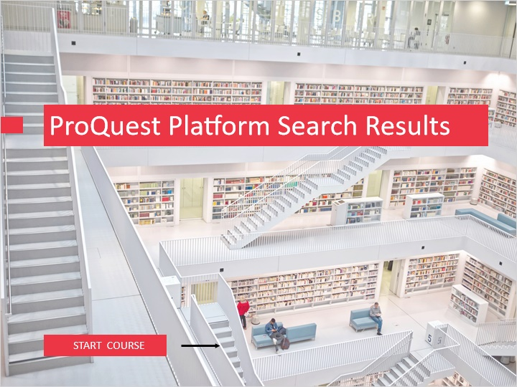
Notes:
Welcome to “ProQuest Platform Search Results.”

The ProQuest platform is found at www.proquest.com, and is an aggregation of databases and search resources your institution may subscribe to or own.

This module will cover the features in search results.

To begin, click on the START COURSE button.

1.3 Objectives
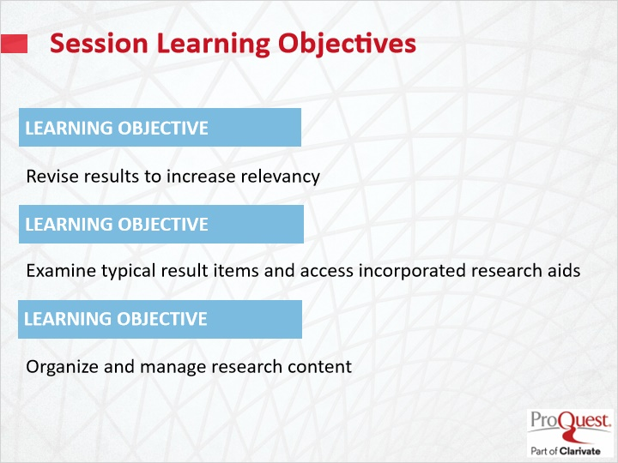
Notes:
The learning objectives for this session are

Revise results to increase relevancy.

Examine typical result items and access incorporated research aids.

Organize and manage research content.

1.4 Search Results Page
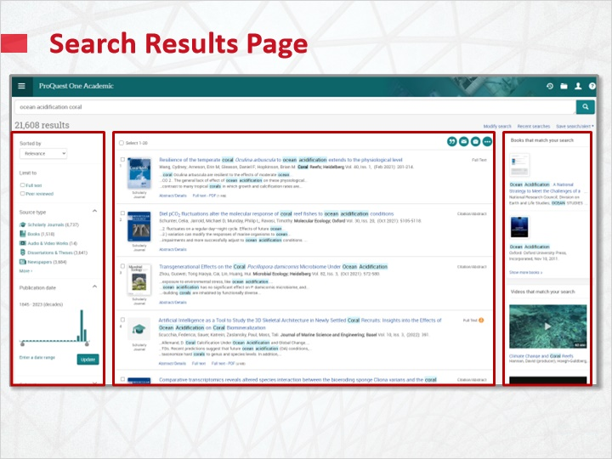
Notes:
The ProQuest platform results page includes three main sections. The center section lists search results details. The right sidebar displays, when available, the most relevant ebooks or video results from a search for easy visibility and quick access. And, the left sidebar gives facets, where search results may be revised to increase search accuracy.

In search results facets, you may sort your results either by keyword relevance, oldest article, or most recent article. Whichever sort you choose will remain as default in your search session until you make a change. You may also limit searches to Full text or Peer reviewed content.

Publication date limit options are also provided.

The remaining choices include limiting by Source type, Subject, Document type, Language, and Publication title. When these are expanded, clicking the More link will open a window that allows a full listing of available limiters. You may sort these alphabetically or by the count associated with a limiter. Once you have found a desired limiter, you may either choose to Include or Exclude the limiter in your search results.

Search Results Facets (Slide Layer)
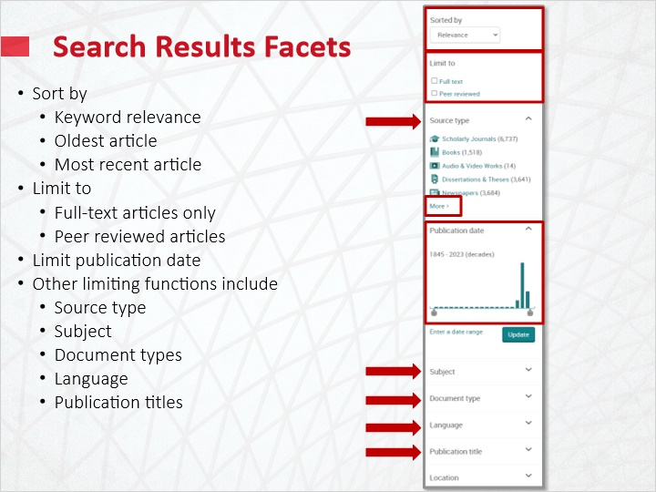

Search Results Facets Source Type (Slide Layer)
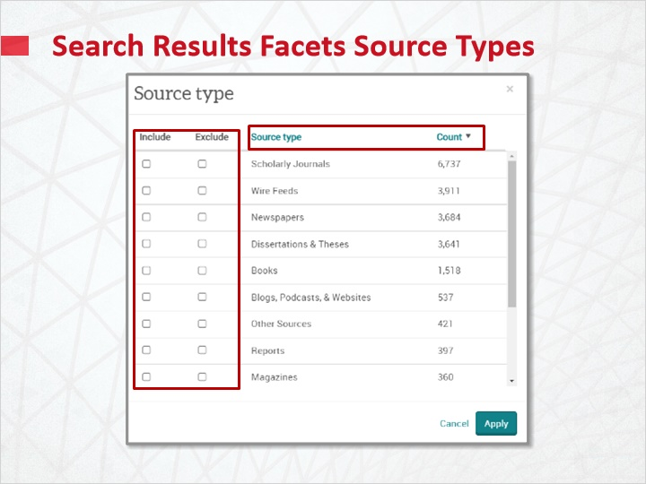

1.5 Search Results List
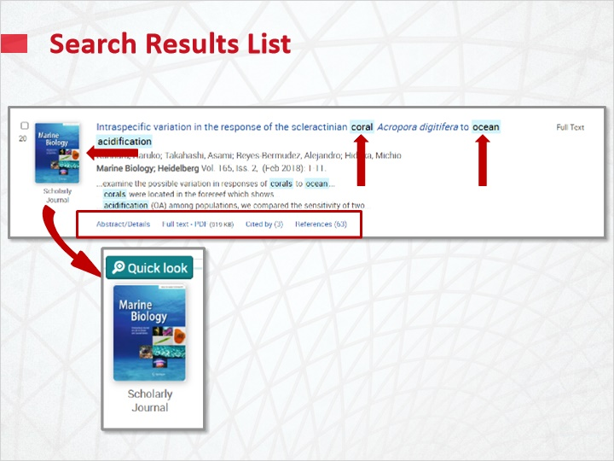
Notes:
In the search results list, if you searched keywords, those terms will be highlighted to facilitate identification of the most relevant results.

There are multiple options which may appear below a result listing. Among those are links to Abstract/Details, and Full text or PDF. For some dissertations, the option to Order a copy may show. Also in some results, links to lists of References used and items the document was Cited by may be provided.

The Source type icon is shown on the upper left.

Hovering over the source icon and clicking Quick Look will open a window where you can view an abstract, associated subject links, and expand to see ProQuest databases where the article may be found.

Search Results Quick Look (Slide Layer)
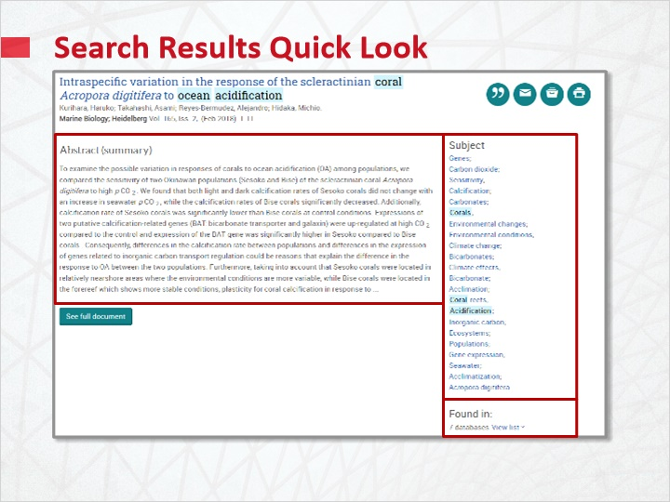

1.6 Document View
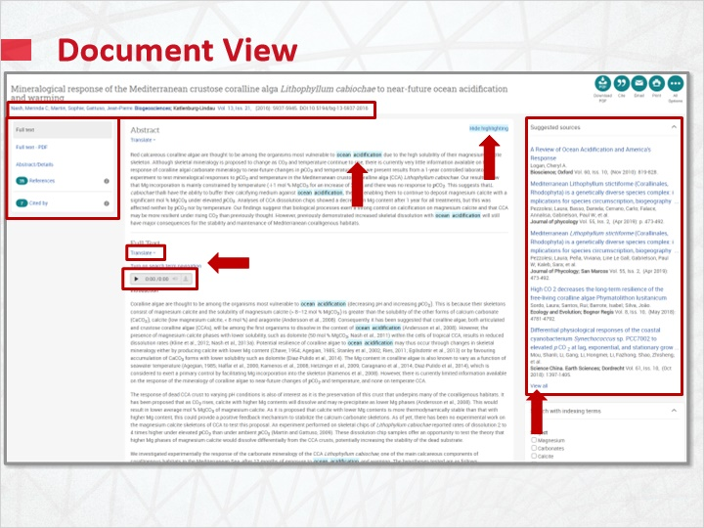
Notes:
Depending upon the type of document you have, article options will vary. Links to search more content from the authors or journal are provided at the top under the title.
Links on the left sidebar allow direct access to formats or sections of the document that are available, including References. If articles have been Cited by other works or have shared references, links will provide access to listings.
Keyword search terms are highlighted. You may Turn on search navigation with arrows to navigate highlighted keyword search terms. You may alternately select the Hide highlighting link at the top right to remove highlighted keyword search terms.
Selecting the Translate link will provide electronic text translation.
If enabled by your Administrator, text-to-speech is provided for the Full Text, with a downloadable MP3 link to the audio.
The ProQuest platform provides linked Suggested sources for related items, based on the content you have searched, in the right sidebar. Select View all allows users to explore suggested sources in an expanded layout with more context, and helps them better evaluate the recommendations.
On the lower right side, you will see options to refine your search by selecting indexing terms, then clicking Search.

Suggested Sources (Slide Layer)
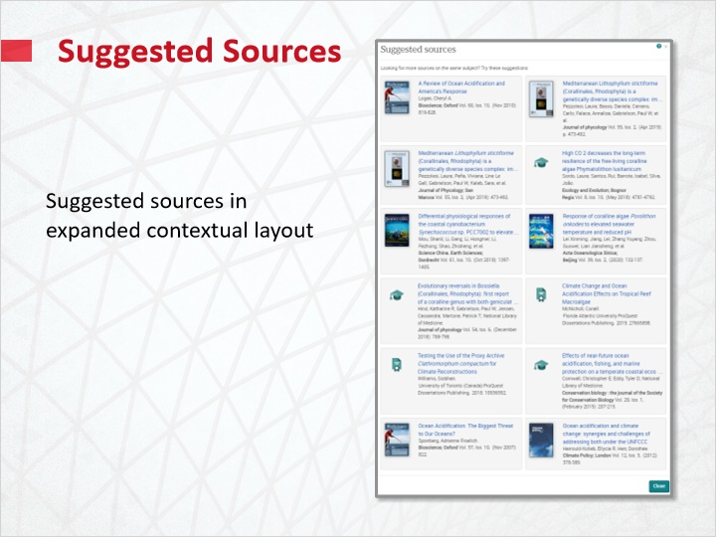

Search with Indexing Terms (Slide Layer)
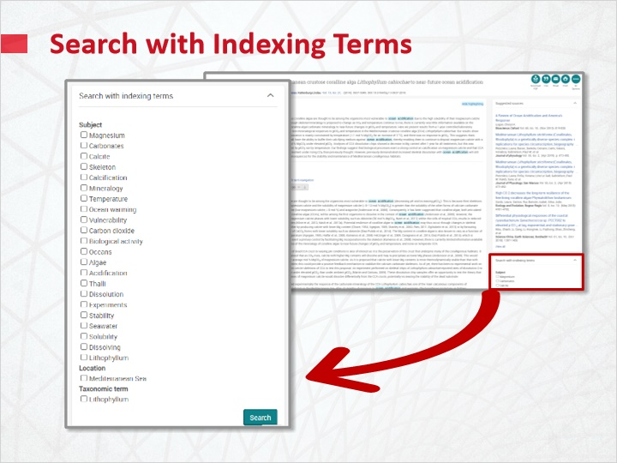

1.7 Working with Searches and Results
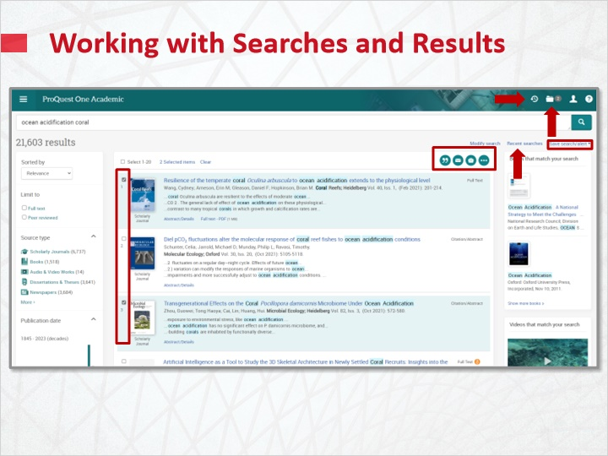
Notes:
On the upper right above search results, you may Save search or create an alert. This link will additionally provide options to create an RSS feed, or create a link to the search that will expire in one year.
To access recent searches, you may either select the link titled Recent searches, or select the clock icon on the upper right page header.
To work with results, start by selecting the checkboxes on the left of each result. Access results you’ve selected from this or other searches in a session by choosing the Folder icon on the upper right page header.
Once items are selected from this search, you may work with them by using the Cite, Email, Print, and Save options.
All of these options are available for items searched during your search session. To work with items for longer periods of time, you will need to use Save to My Research. You will then be prompted to login to your My Research account or create a free My Research account if you have not already done so.
In My Research, you may organize items into Folders, Manage Folders, and Add notes. You may also manage or modify saved Searches, Alerts, and RSS Feeds.

Save Options (Slide Layer)
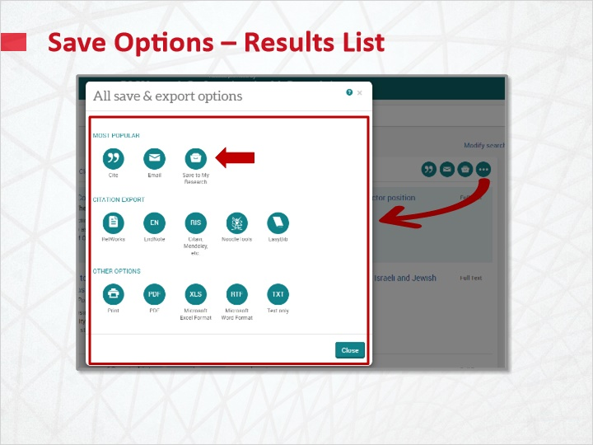

My Research (Slide Layer)
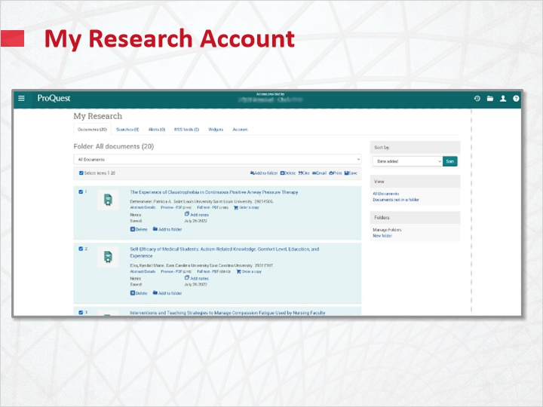

1.8 Test Your Knowledge
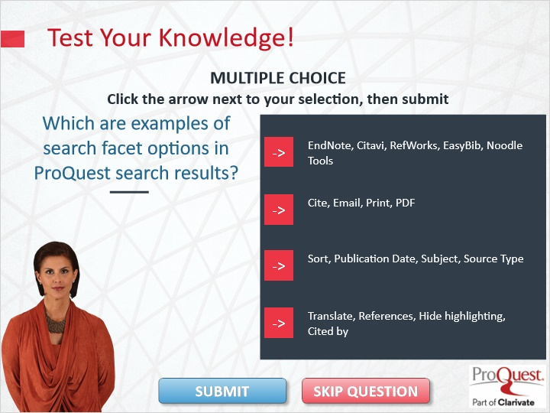

Notes:
Test Your Knowledge!

Click the arrow next to your selection, then submit to check your answer.

Which are examples of search facet options in ProQuest search results?

The correct answer is Sort, Publication Date, Subject, Source Type. Press continue to move on.

1.9 Summary
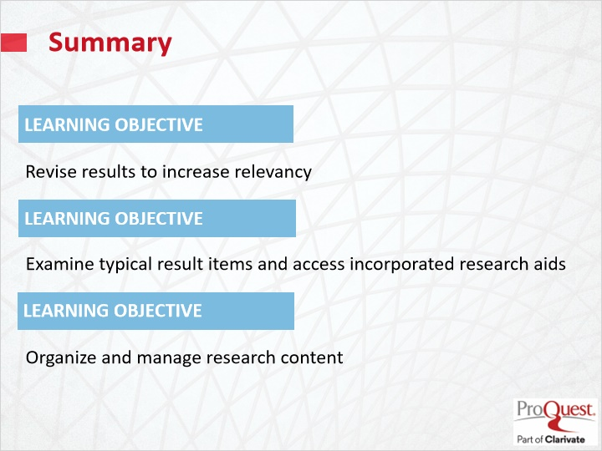
Notes:
In summary, the learning objectives for this session have been to

Revise results to increase relevancy.

Examine typical result items and access incorporated research aids.

Organize and manage research content.

1.10 Thank you!
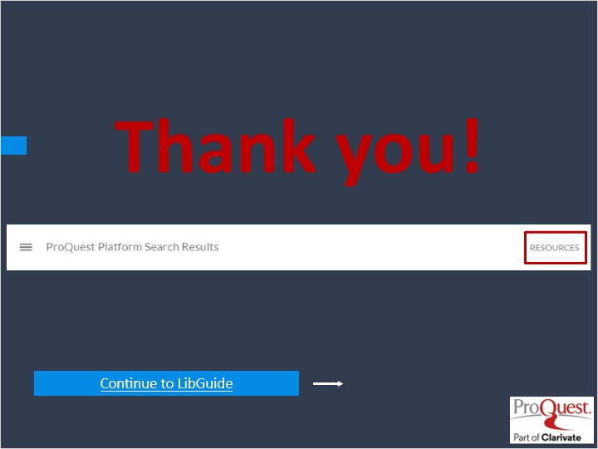
Notes:
This concludes this session. Thank you for joining! To learn more, please click on the Resources link, as illustrated, in the upper right corner of this session player, or visit our ProQuest Platform LibGuide page by clicking the LibGuide link at the bottom of this screen.

1.11 Copyright
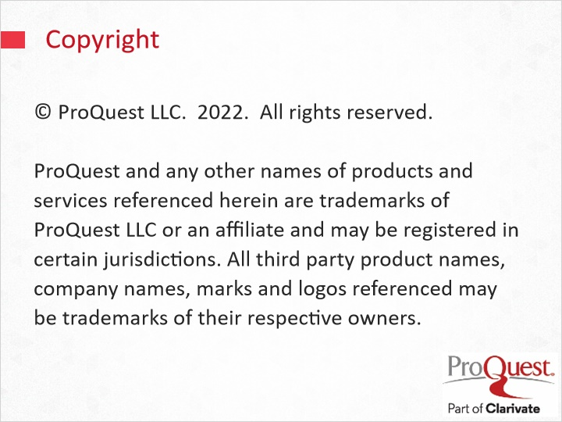
Notes:
© ProQuest LLC. 2020. All rights reserved.
ProQuest and any other names of products and services referenced herein are trademarks of ProQuest LLC or an affiliate and may be registered in certain jurisdictions. All third party product names, company names, marks and logos referenced may be trademarks of their respective owners.

