Academic Video Online on ProQuest

1. Public / Academic Library Template

1.1 Introduction

Notes:

1.2 Academic Video Online on ProQuest
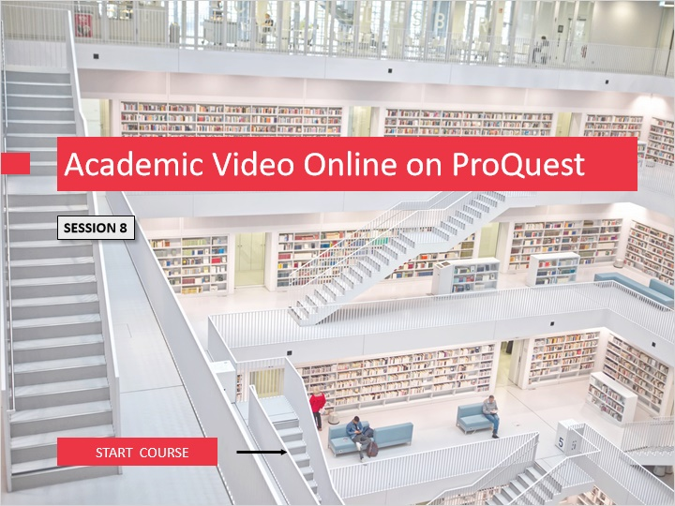
Notes:
Welcome to the eighth learning module for the ProQuest platform. This learning module is titled “Academic Video Online on ProQuest” and will focus on finding and using Academic Video Online content at your local institution on the ProQuest platform. Prior to taking this module, you should have completed the ProQuest Platform Basic Search, Advanced Search, and Search Results modules. To begin, click on the START COURSE button.

1.3 Objectives
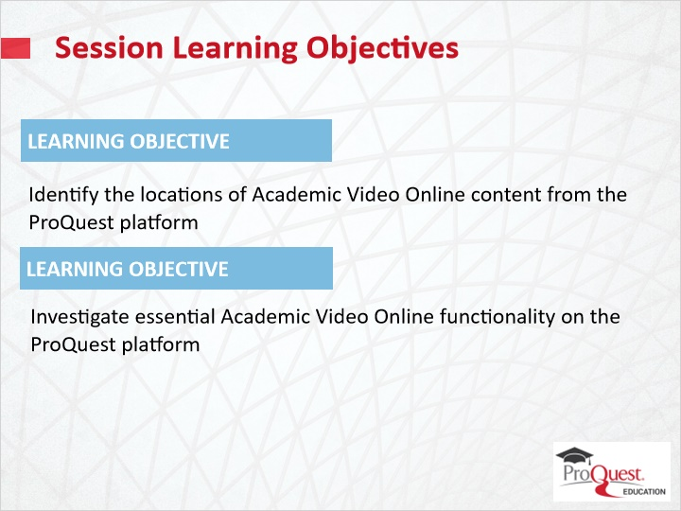
Notes:
The learning objectives for this session are

To identify the locations of Academic Video Online content from the ProQuest platform and to investigate essential Academic Video Online functionality on the ProQuest platform.

1.4 Location of Academic Video Online
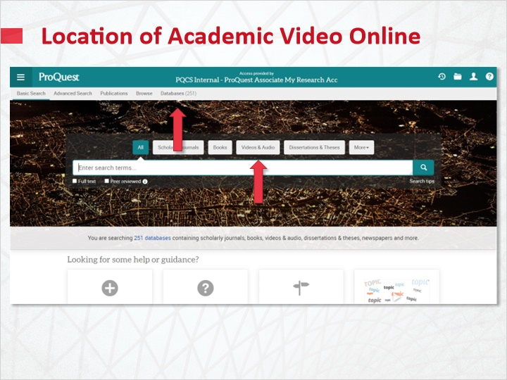
Notes:
Your local institution’s Academic Video Online content is discoverable as a database collection along with your other existing ProQuest platform resources.

All video content in your ProQuest collections may be isolated by selecting Videos & Audio in Basic Search before running a search. Doing this will not, however, exclusively isolate Academic Video Online content. It will search all content within your ProQuest collections indexed as video content, including Academic Video Online.

Because Academic Video Online on ProQuest works similarly to any journal database, to search only Academic Video Online, you may go to the Databases tab, locate the database link, and you will be taken to a Basic Search page specifically for Academic Video Online.

From here, you may select Advanced Search to narrow using Document Type, Language, and searchable fields.

Academic Video Online database page (Slide Layer)
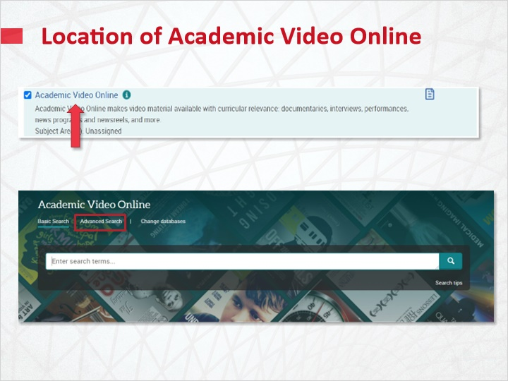

Academic Video Online advanced search (Slide Layer)
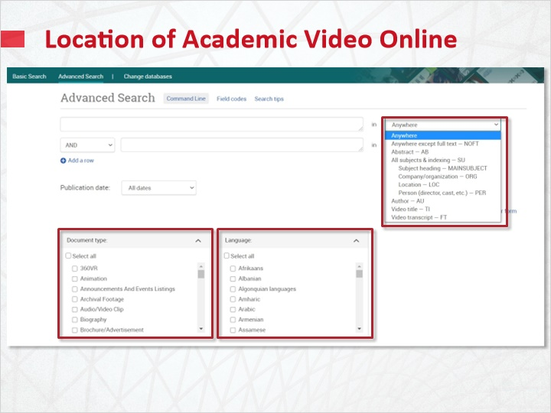

1.5 Search Results
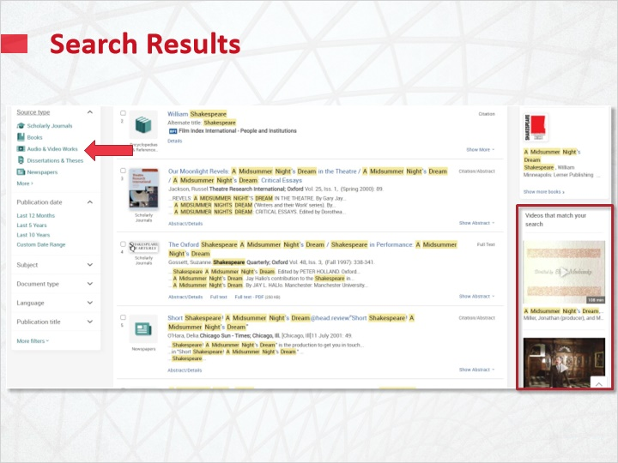
Notes:
In search results, the most relevant keyword searched video content, including Academic Video Online content, will be visible along the right sidebar. To limit your results list to either audio or video content, select the filter titled Audio & Video Works under Source Type.

The main results list will now list only audio or video content. This may include video content not from Academic Video Online as well as content from Academic Video Online. Academic Video Online content will include links to the start of each video, and targeted links to relevant sections from the video and its transcript, based upon the keywords searched.

Search Results Video filter (Slide Layer)
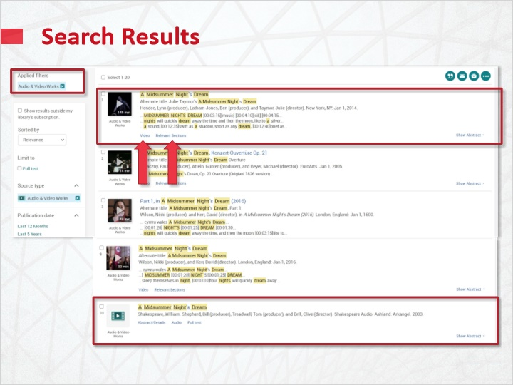

1.6 Video Results
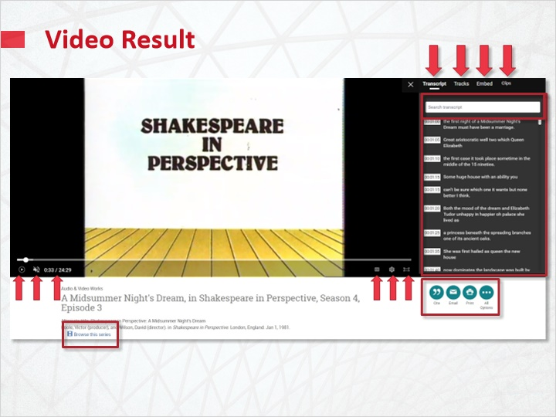
Notes:
In a video result, a readable transcript is available. You may search each transcript for key terms. If the video offers tracks, you may view and select those tracks as well. Links to the embed codes are available for sharing or embedding in an LMS or other website. When public clips have been saved in the Academic Video Online platform, a link to those clips may also be provided.

The left video player menu may include play/pause button, volume controls, and the timestamp. The right video player menu may include onscreen transcript or Closed Captions, video quality settings, and fullscreen view mode. On the right side of the screen are citing, print, and email functions, along with other options for sharing or saving this item. If videos are in a series, you may browse the videos from the series.

Below the video player, you may access the Abstract, and bibliographic Details -- many of which may have searchable links. You can also search ProQuest for further content using the box on the right side of the screen. Related Items are suggested by the search engine, and you may additionally search for more information by using indexing terms.

Video Result details (Slide Layer)
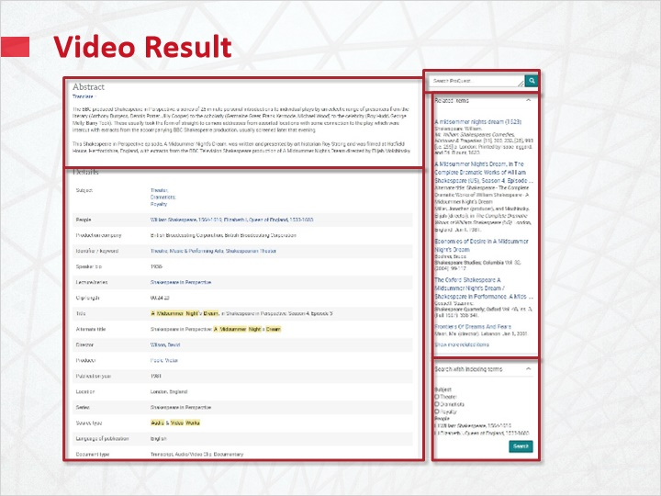

1.7 Test Your Knowledge
(Pick One, 10 points, unlimited attempts permitted)
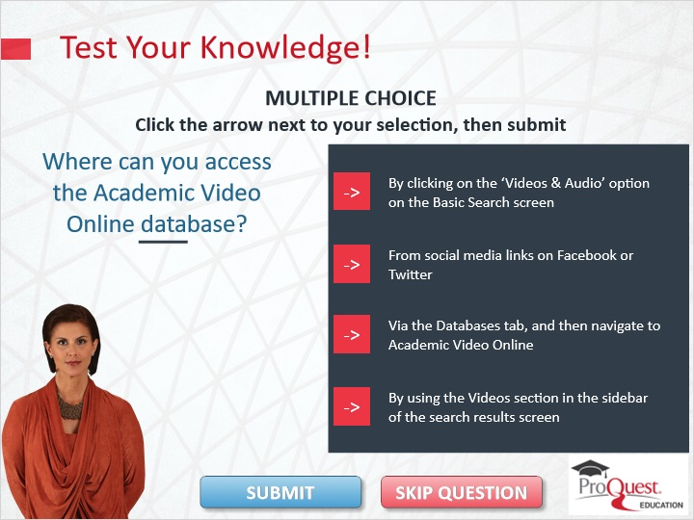
Correct | Choice | Feedback
 | Choice A | The correct answer is via the databases tab, and then navigate to Academic Video Online.
 | Choice B | The correct answer is via the databases tab, and then navigate to Academic Video Online.
X | Choice C | Congratulations!
 | Choice D | The correct answer is via the databases tab, and then navigate to Academic Video Online.

Notes:
Test Your Knowledge!

Click the arrow next to your selection, then submit to check your answer.

Where can you access the Academic Video Online database?

Incorrect. The correct answer is via the databases tab, and then navigate to Academic Video Online. Press continue to move on.

That’s correct. Congratulations! Press Continue to move ahead.

1.8 Summary
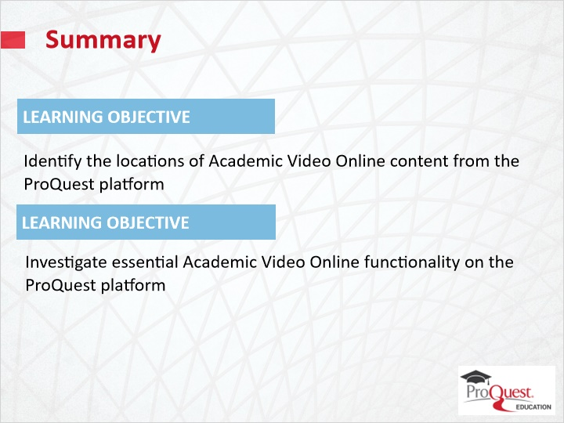
Notes:
This session has covered the following learning objectives

To identify the locations of Academic Video Online content from the ProQuest platform and to investigate essential Academic Video Online functionality on the ProQuest platform.

1.9 Thank you!
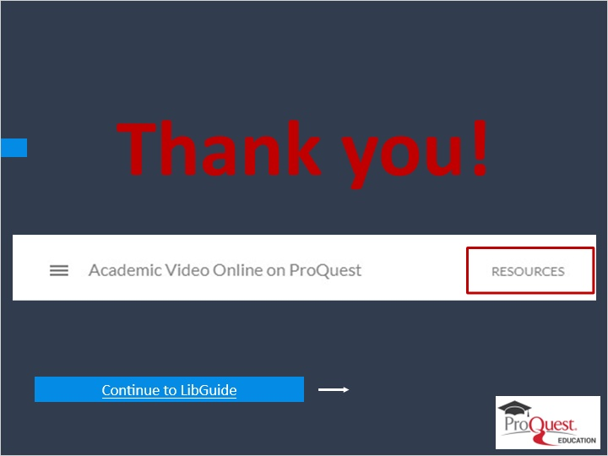
Notes:
This concludes this session. Thank you for joining! To learn more, please click on the Resources link, as illustrated, in the upper right corner of this session player, or visit our ProQuest Platform LibGuide Product page by clicking the LibGuide link at the bottom of this screen.

1.10 Copyright
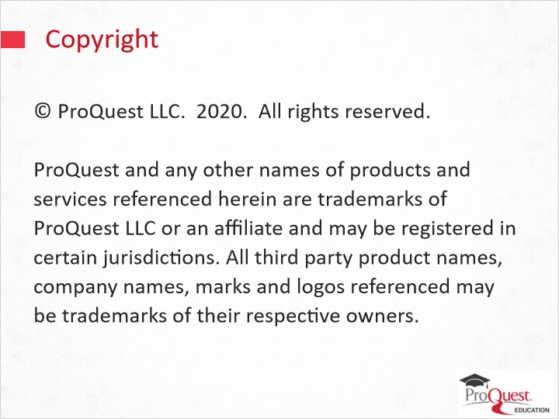
Notes:
© ProQuest LLC. 2020. All rights reserved.
ProQuest and any other names of products and services referenced herein are trademarks of ProQuest LLC or an affiliate and may be registered in certain jurisdictions. All third party product names, company names, marks and logos referenced may be trademarks of their respective owners.

