PQP_ProQuestOneAcademic_FromSearchtoBibliography

1. ProQuest One Academic: From Search to Bibliography

1.1 ProQuest One Academic
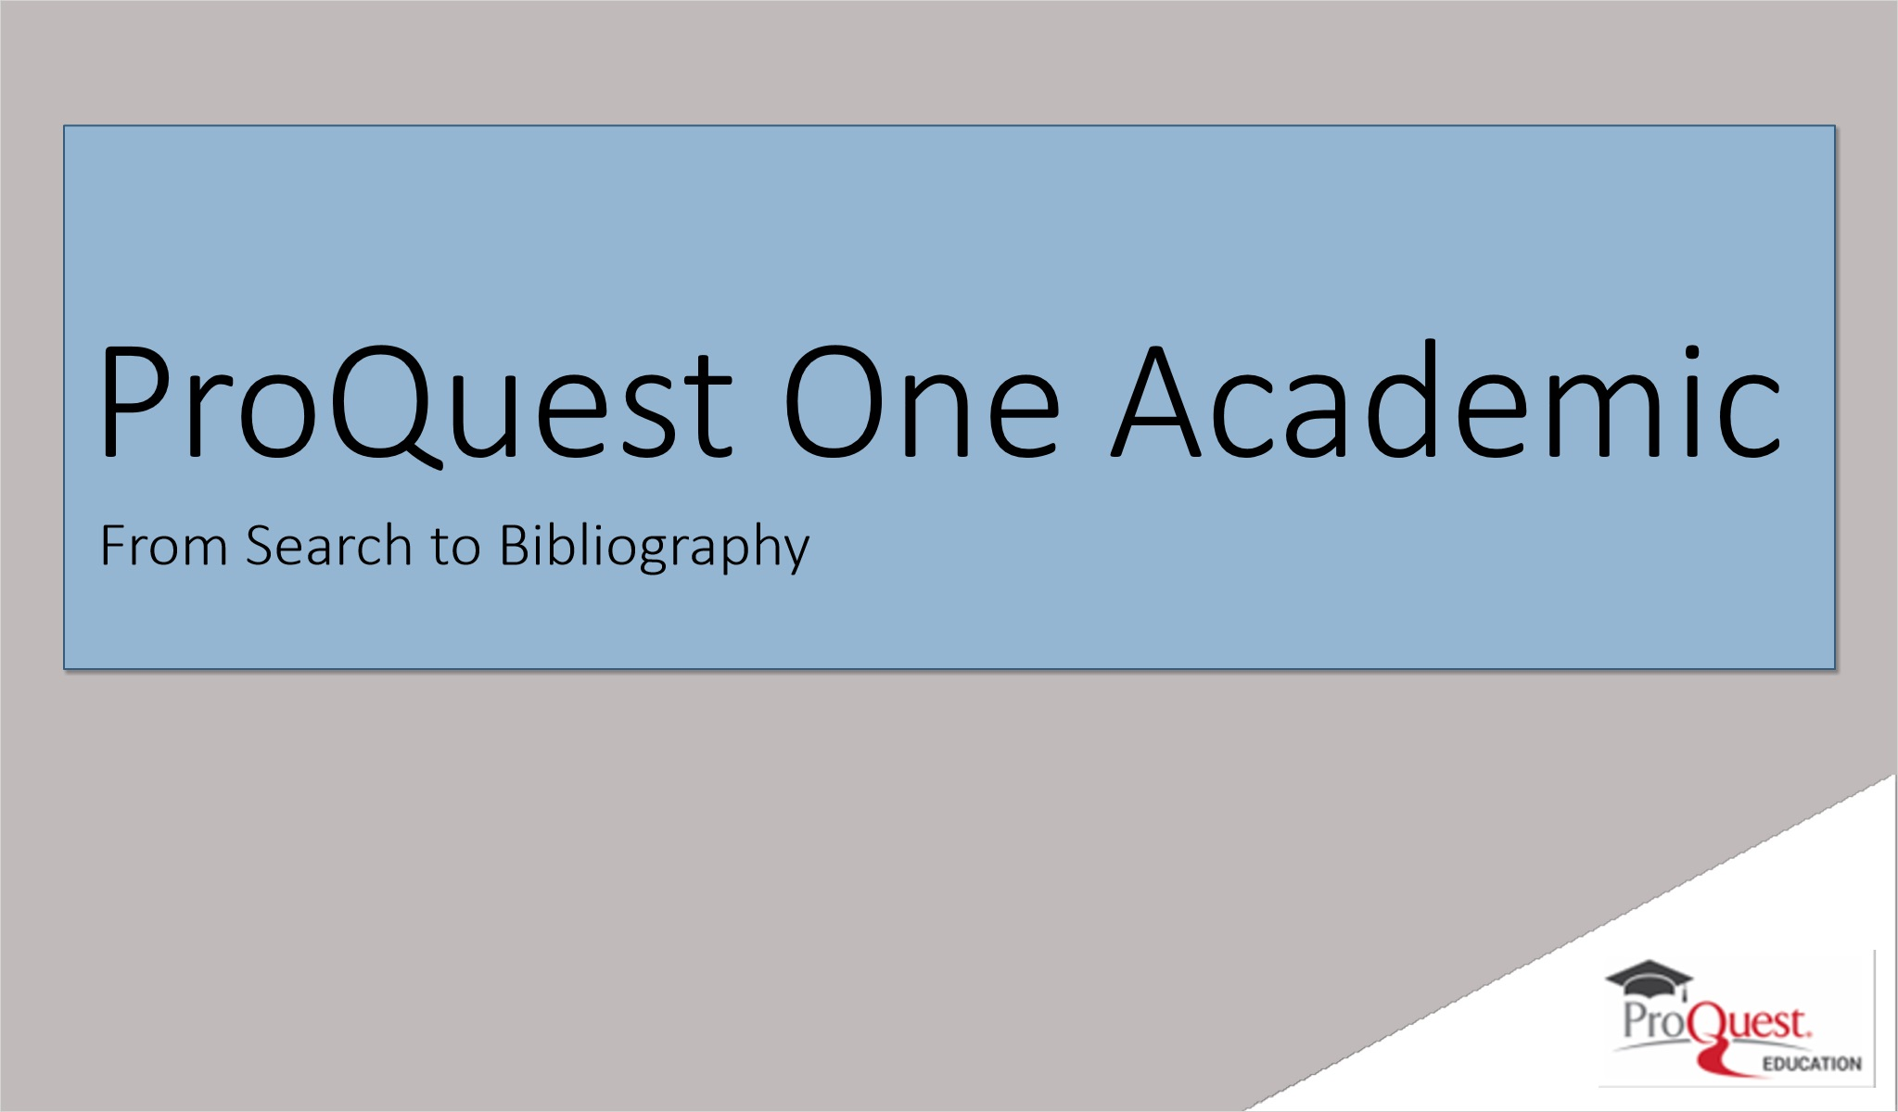
Notes:
Welcome to ProQuest One Academic: From Search to Bibliography.

As a research, teaching and learning solution, ProQuest One Academic brings our most used multi-disciplinary collections together on the ProQuest platform, and provides a wide range of research materials such as scholarly journals, books, dissertations, streaming video, and more from a single access point.

1.2 Session Objectives
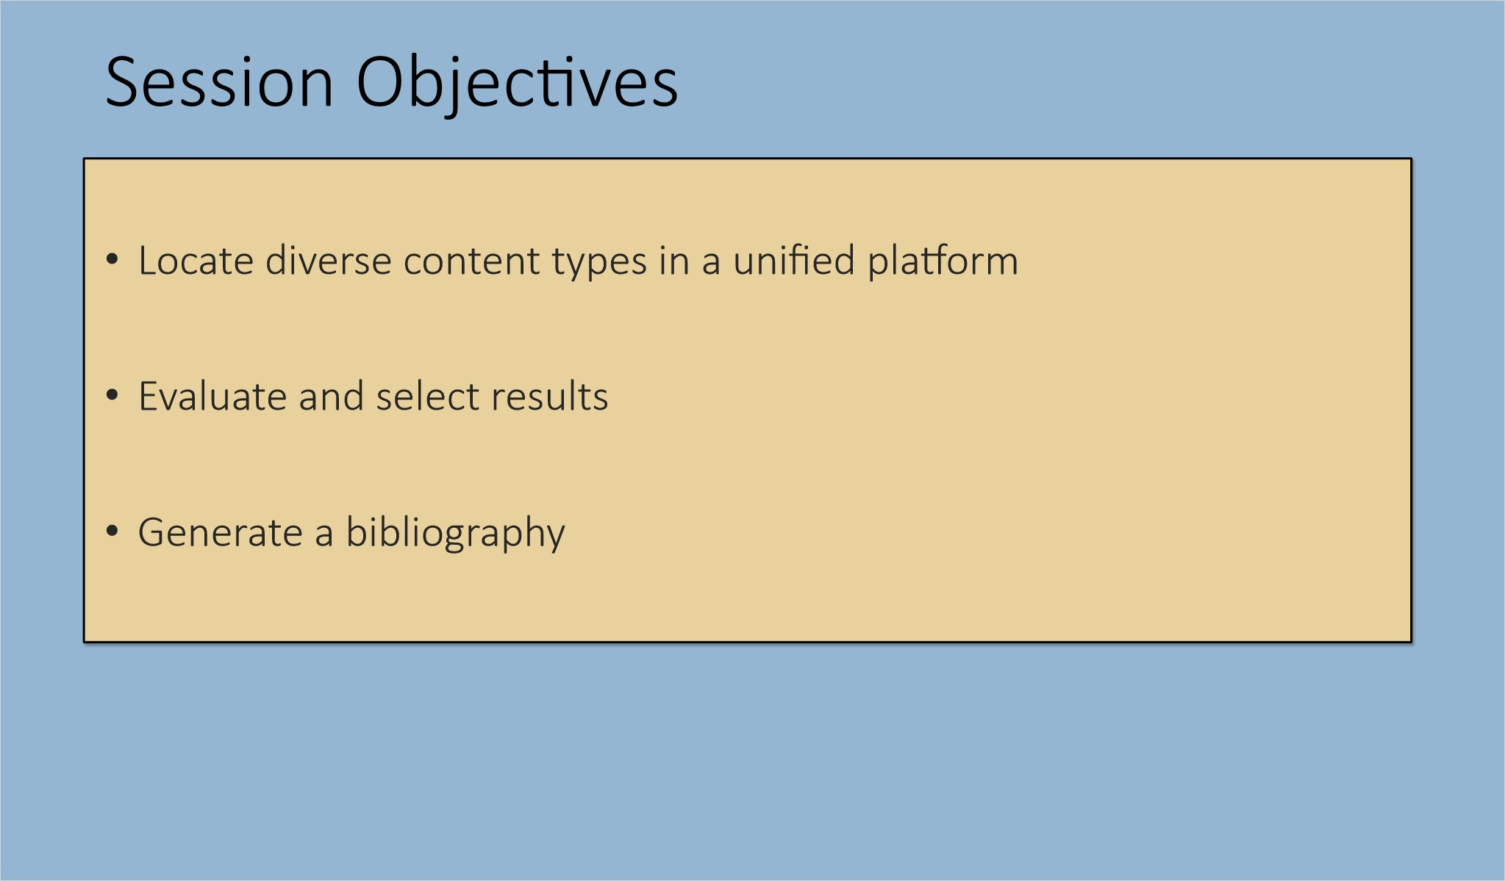
Notes:
At the end of this session, you will be able to locate diverse content types using a unified search platform and evaluate and select results. You will also be able to generate a bibliography with your results from ProQuest One Academic.

1.3 Where to Start?
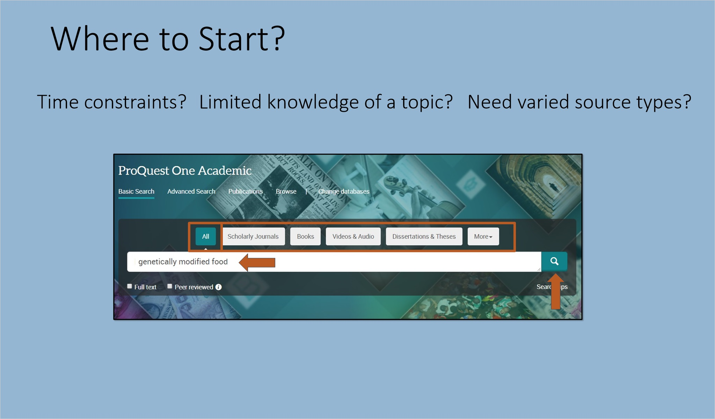
Notes:
The question “Where do I start?” with a research project is common. Researchers may have time constraints, novice search skills, or limited knowledge of a topic. They often require diverse source types to meet class requirements or get a broad view of a topic. As a reference librarian or instructor helping others quickly learn to navigate the search experience, or as a researcher ready to begin, start with ProQuest One Academic.

Using Basic Search, you can search across all content types or choose a specific type of research material. Type your search query in the Basic Search box and run the search. This example searches across all source types.

1.4 Results – Locating Varied Content Quickly
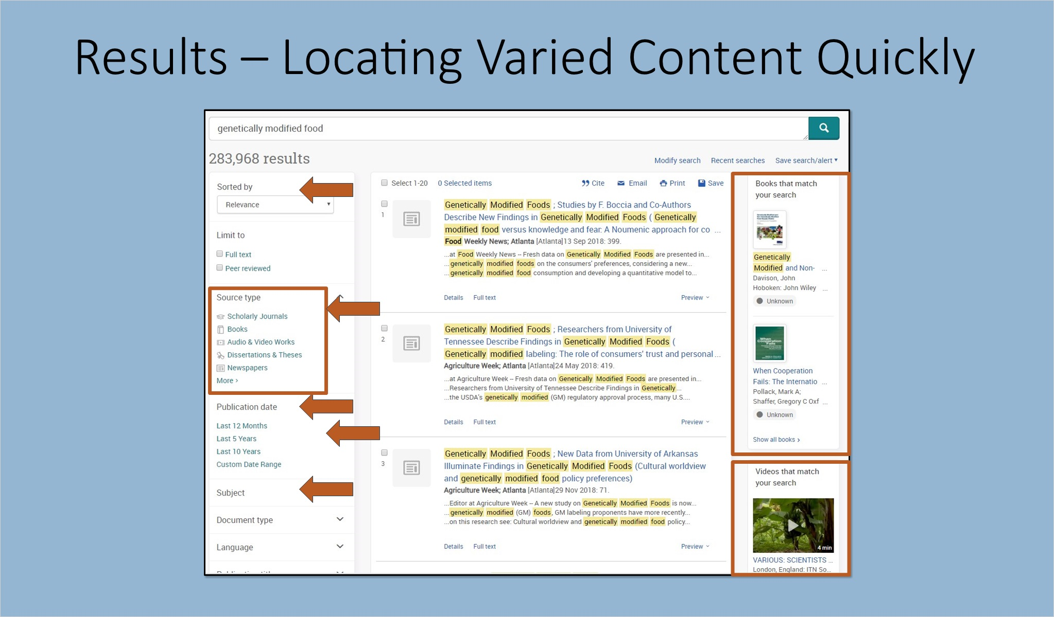
Notes:
The left side of the results page shows sort options and filters such as Subject and Publication date along with a filter for Source Type. The Source Type filter quickly provides an overview of resources available with one search, and allows the researcher to choose a specific source kind, such as Scholarly Journals, Books, Audio & Video Works, Dissertations & Theses, News and More. This can be especially helpful where the researcher has been asked to gather relevant results from a variety of content types.

Electronic Books and Videos that match your search appear on the right.

Choose Scholarly Journals to filter to that type of content. Use other filters to refine the search as desired. Clicking the Publication date filter Last 5 Years after applying the Scholarly Journals filter focuses on recent information, as shown in the results on the next slide.

1.5 Scholarly Journals
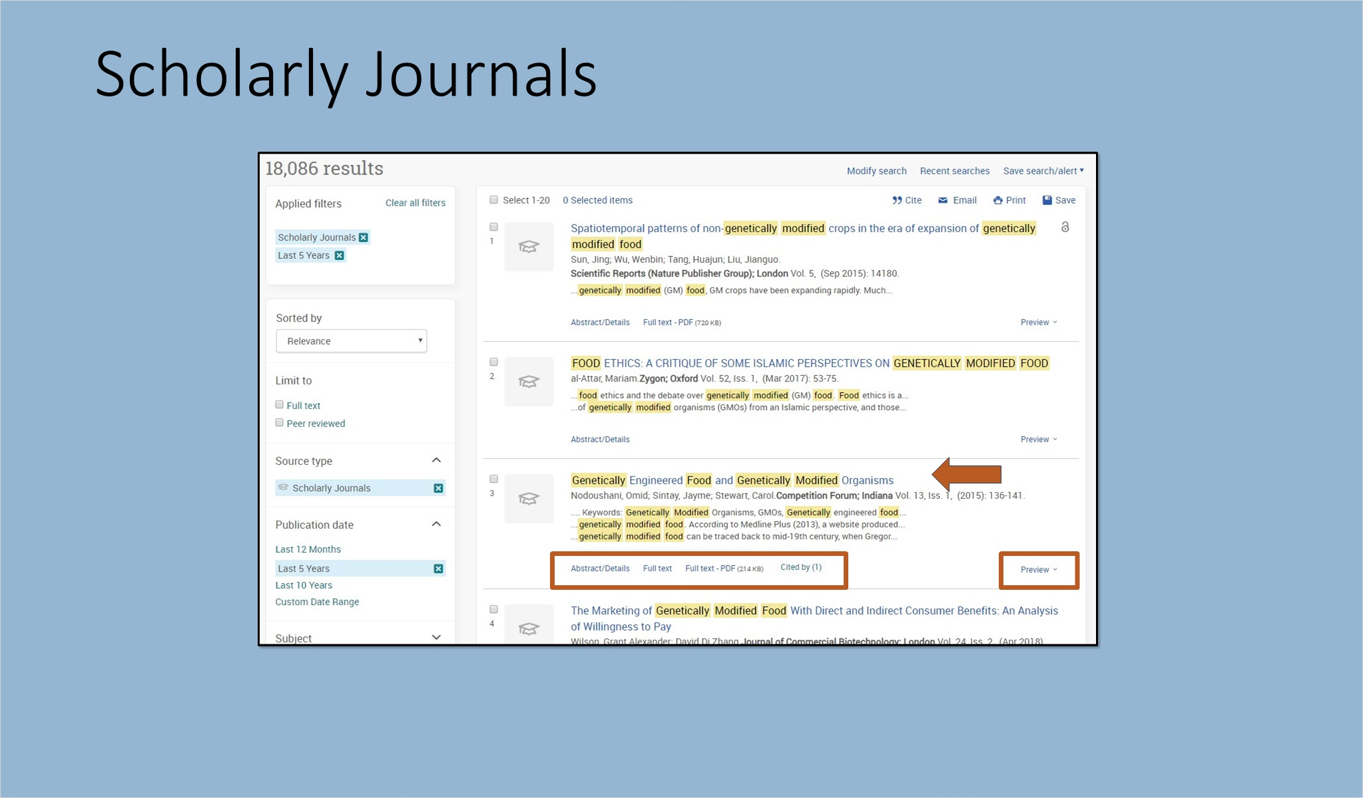
Notes:
Each scholarly journal record has a Preview option. Go directly to the content by clicking the title or one of the display options for the record. Full text and Citations are linked where available.

Find related items for exploring the topic on the lower right in the record display, and options for working with the individual record, including the prominent Download to PDF option, at the top right.

Go back to the results page. Check items of interest.

To filter to another Source type, clear the Scholarly Journals filter by clicking the X next to it.

Display record (Slide Layer)
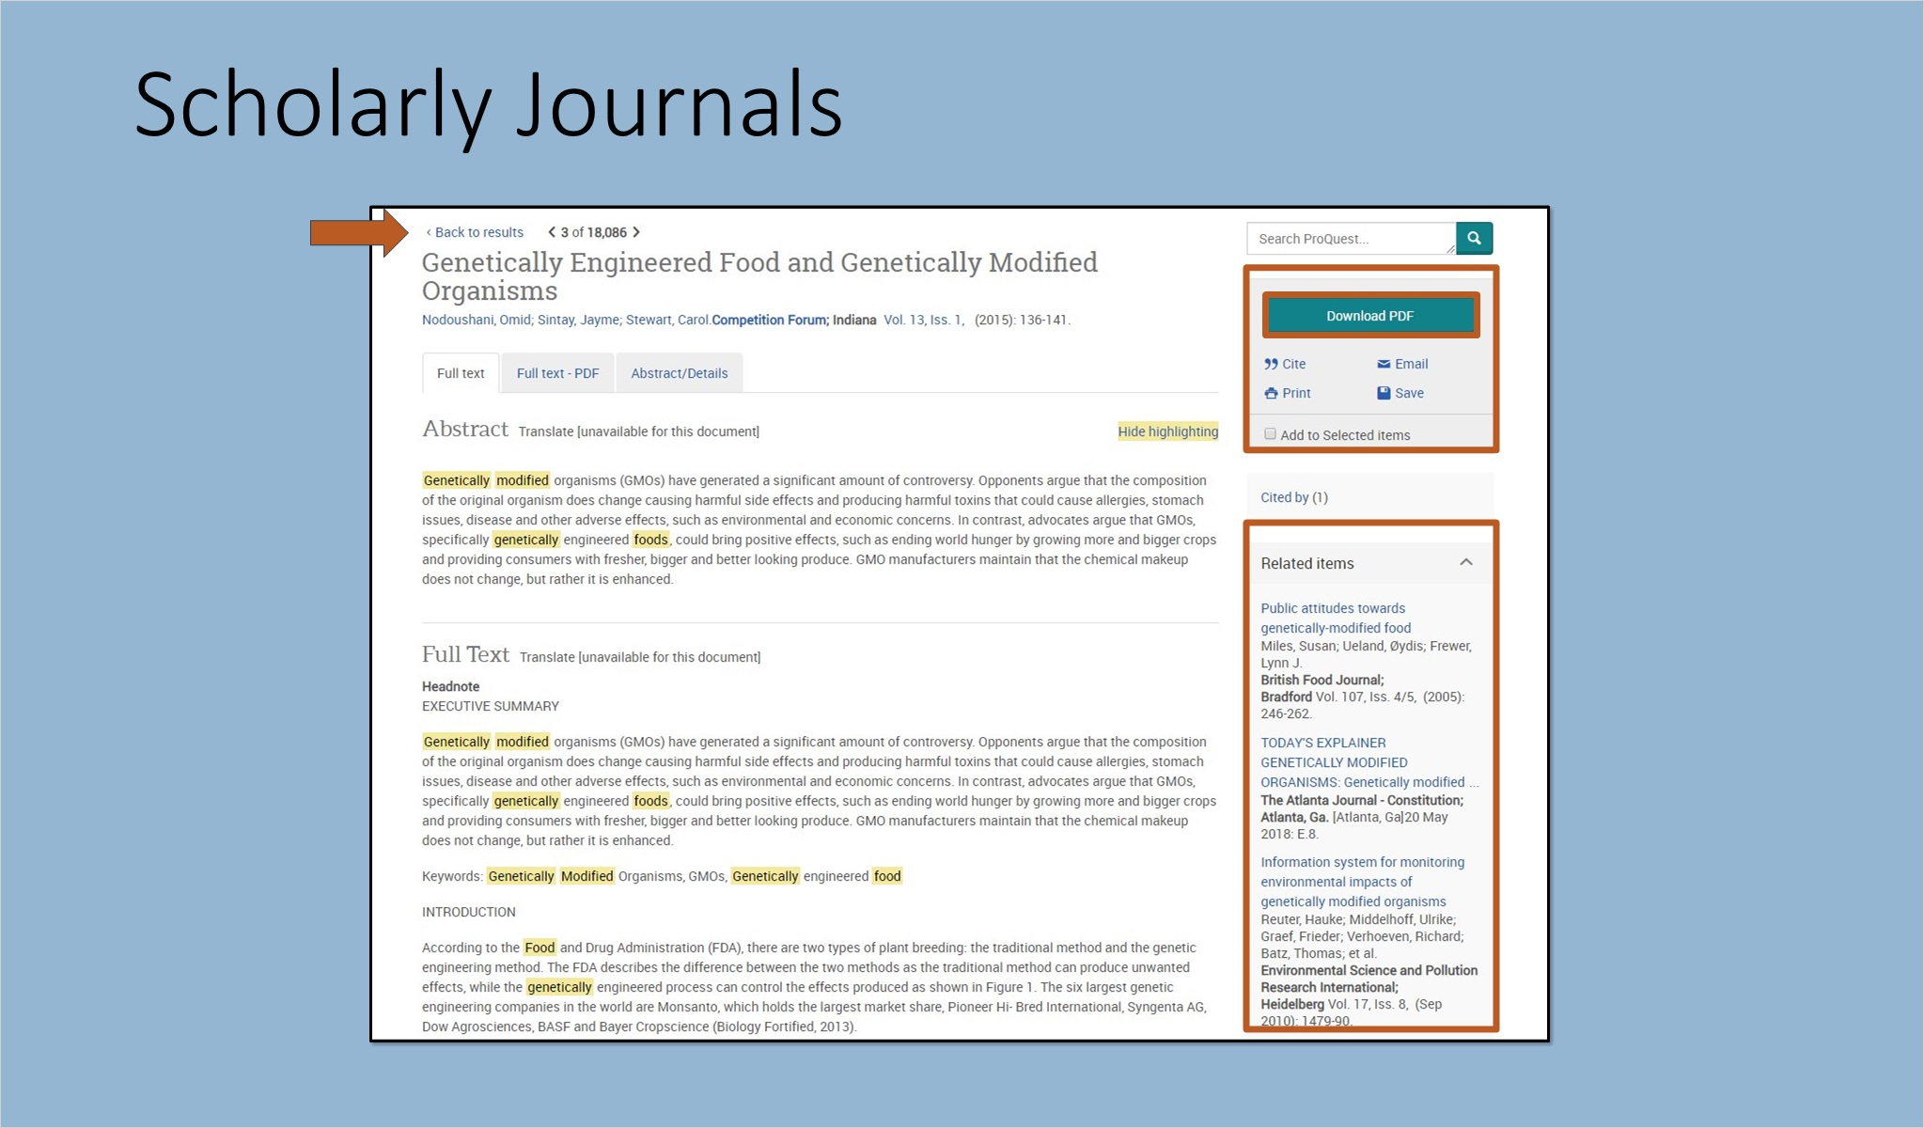

Check items (Slide Layer)
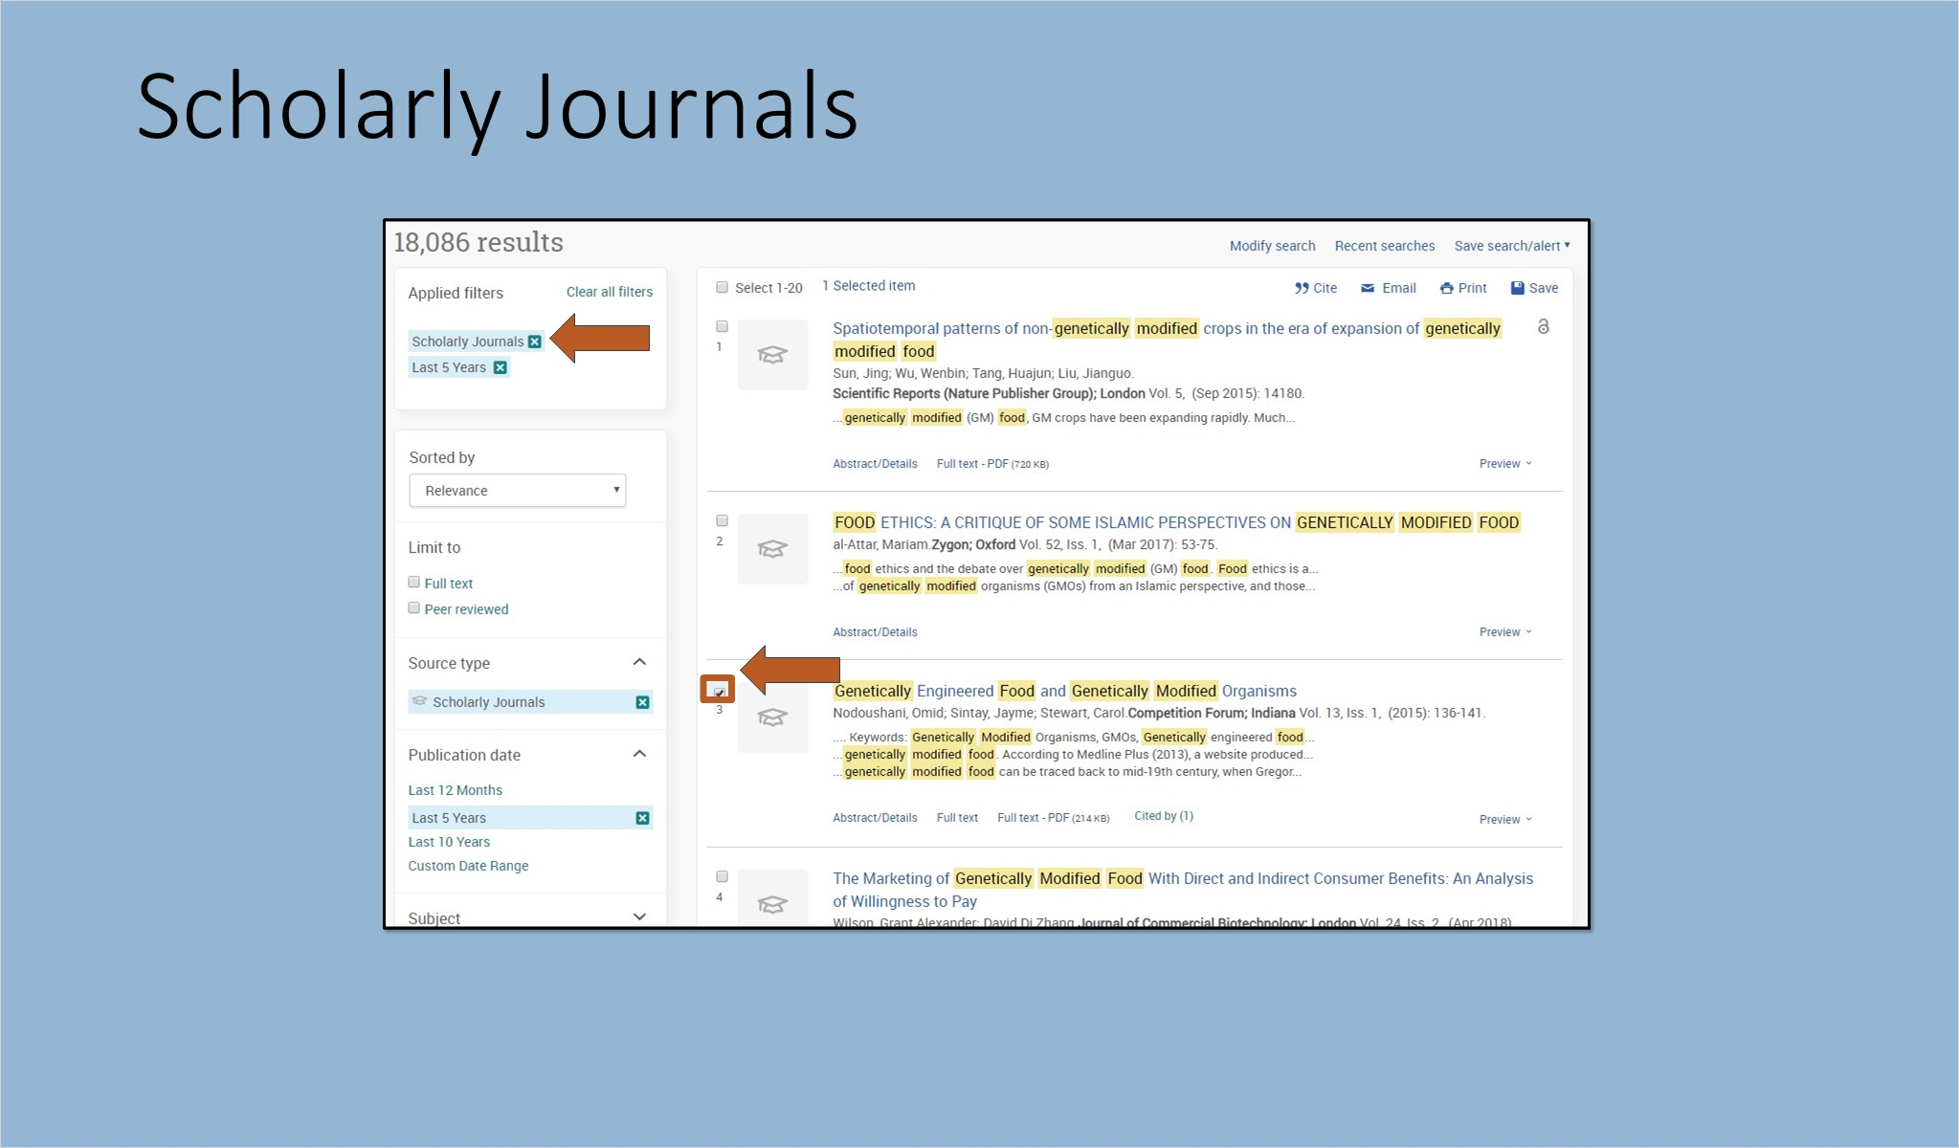

1.6 Books
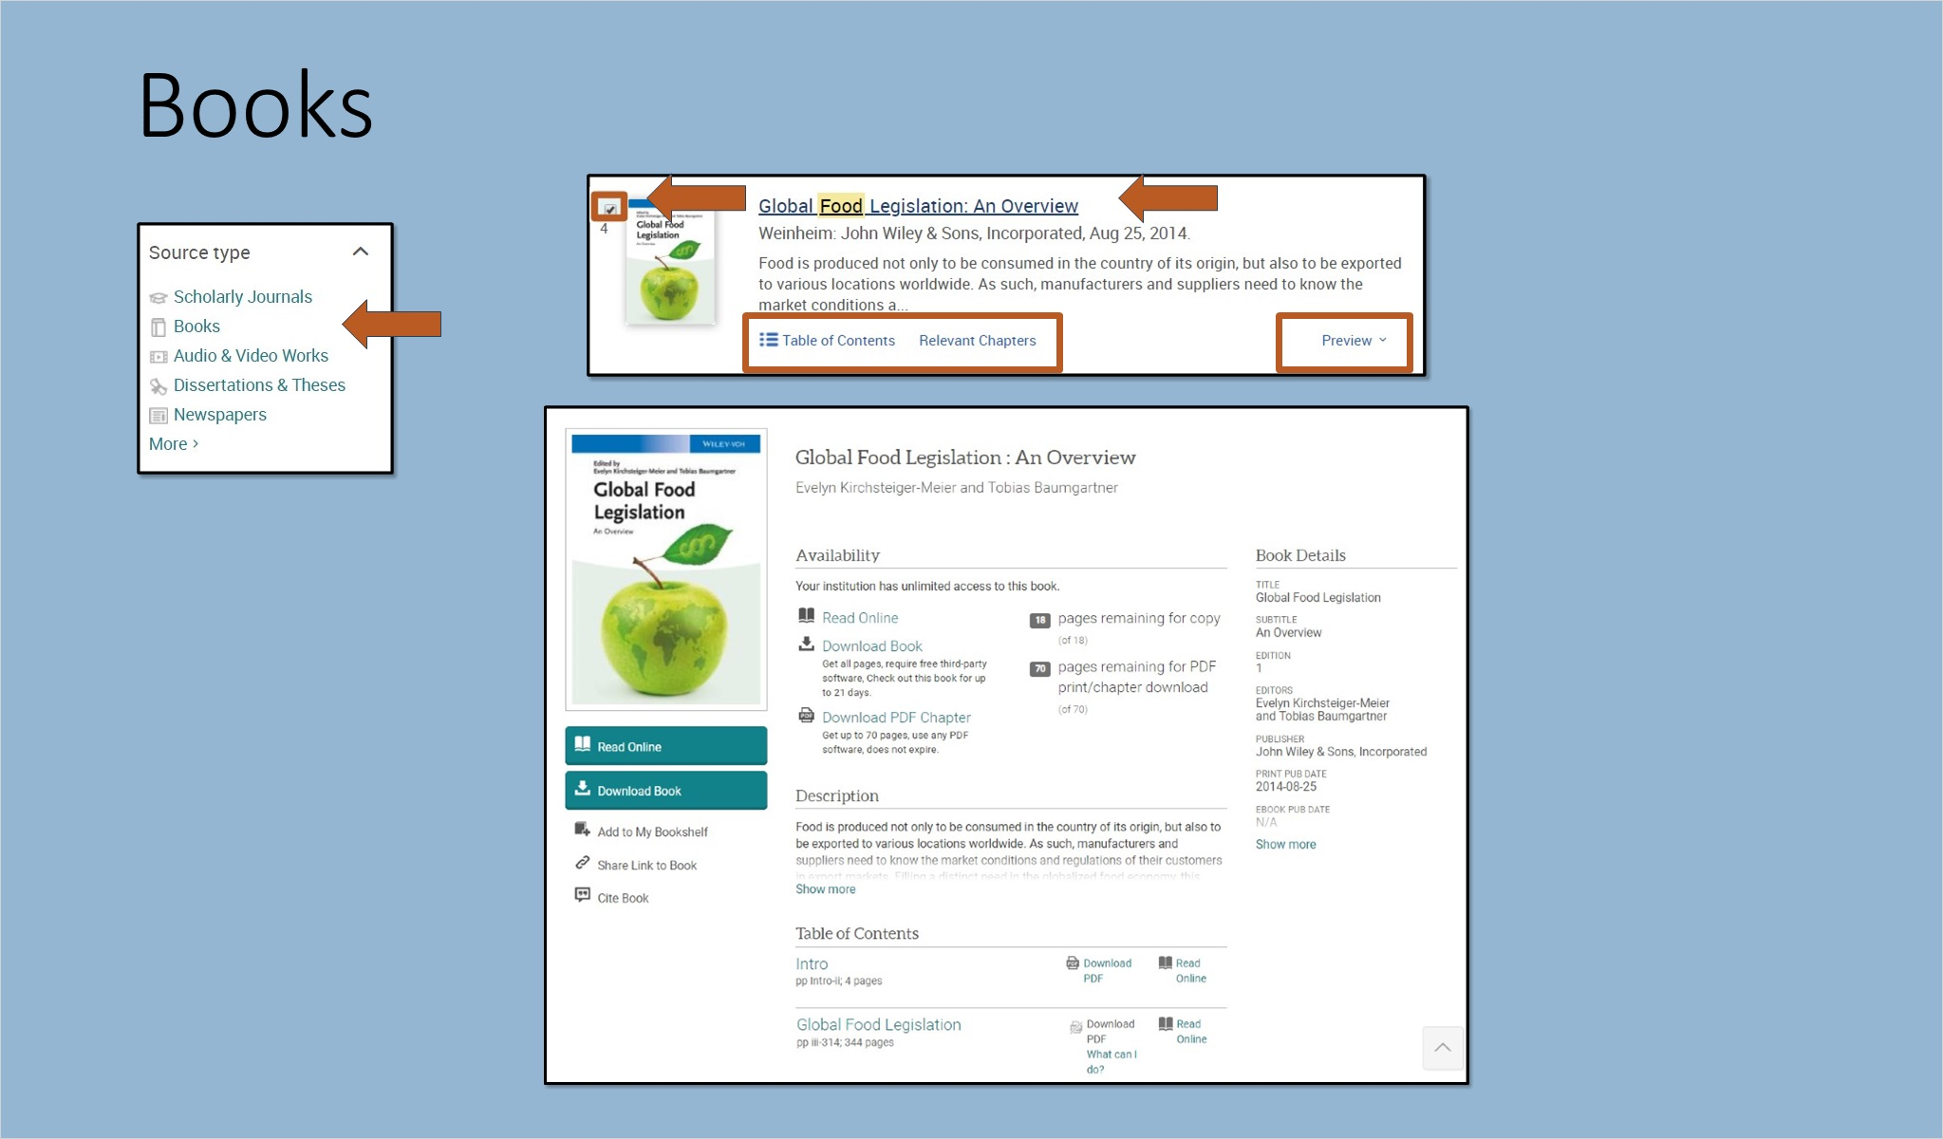
Notes:
Repeat the process with other source types. For example, click Books. Display options for ebooks include Preview, Table of Contents and Relevant Chapters, or click the title to be taken to the book and read online, download the book or individual chapters, or take advantage of many additional options. Like this book? Return to the results list and check it to add to your selected items.

Clear the Books filter from the left panel and choose another source type.

1.7 Video
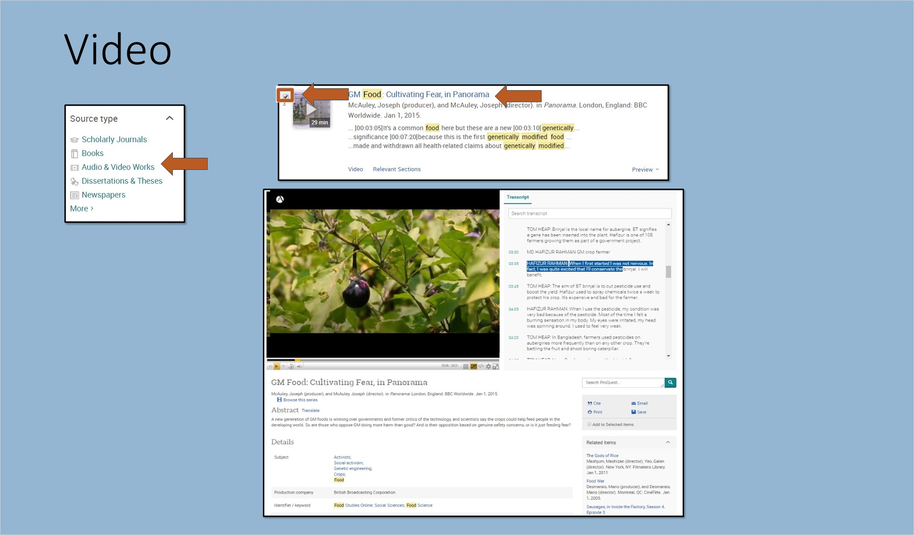
Notes:
The Audio & Video Works filter includes videos with curricular relevance such as documentaries, interviews, performances, news programs, raw footage and more. Videos in ProQuest provide the richness of visual insight.

Again, add items of interest to your selected items.

Clear the Audio & Video Works filter from the left panel when finished.

1.8 Dissertations
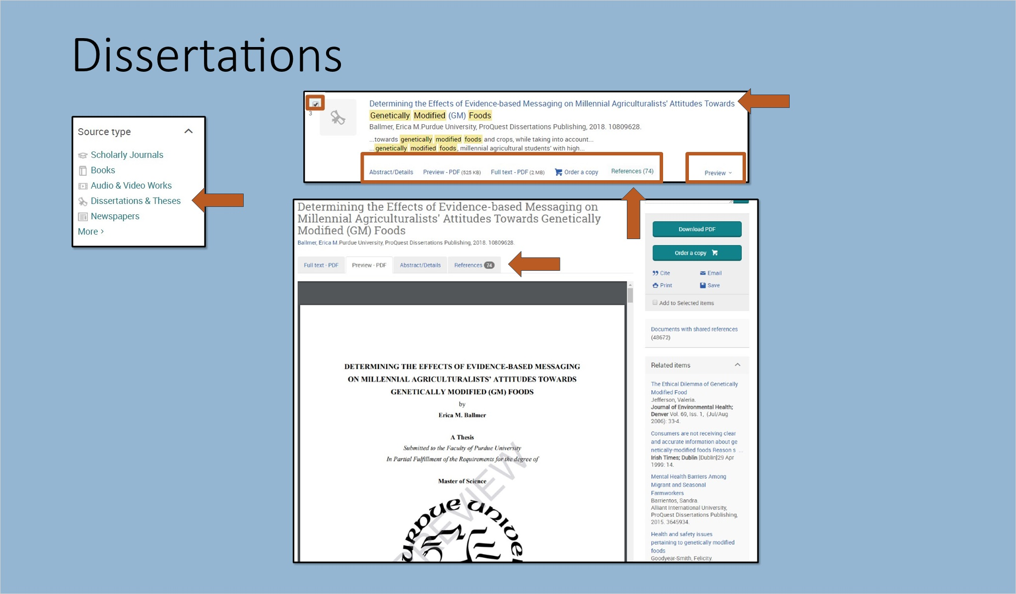
Notes:
The last Source type example for this session is Dissertations & Theses. Dissertations are a key source for the latest scholarly thinking and serve as examples of research. Links to the dissertation References are available in ProQuest One Academic, and can serve as a robust launching point for additional research. Select the dissertation.

1.9 Creating a Bibliography
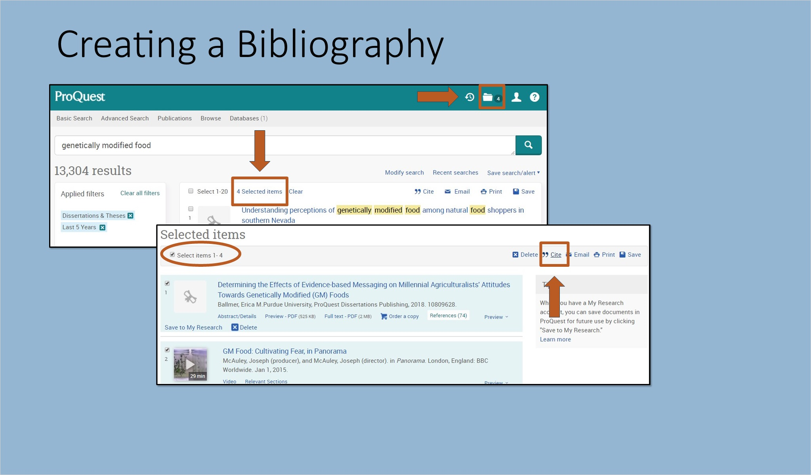
Notes:
To create a bibliography from your selected items, click on the Selected items list at the top of the results listing or in your Folder at the top right. There are 4 items selected from our research: a dissertation, video, book and a scholarly article. It’s easy to create a combined bibliography using the Cite tool. Choose your Citation style from the pull-down menu, then copy and paste the citations into a Word document or email, print or download. Remember to check for accuracy and make any corrections.

RefWorks subscribers can export to RefWorks directly using the Save Option.

Completed Bibliography (Slide Layer)
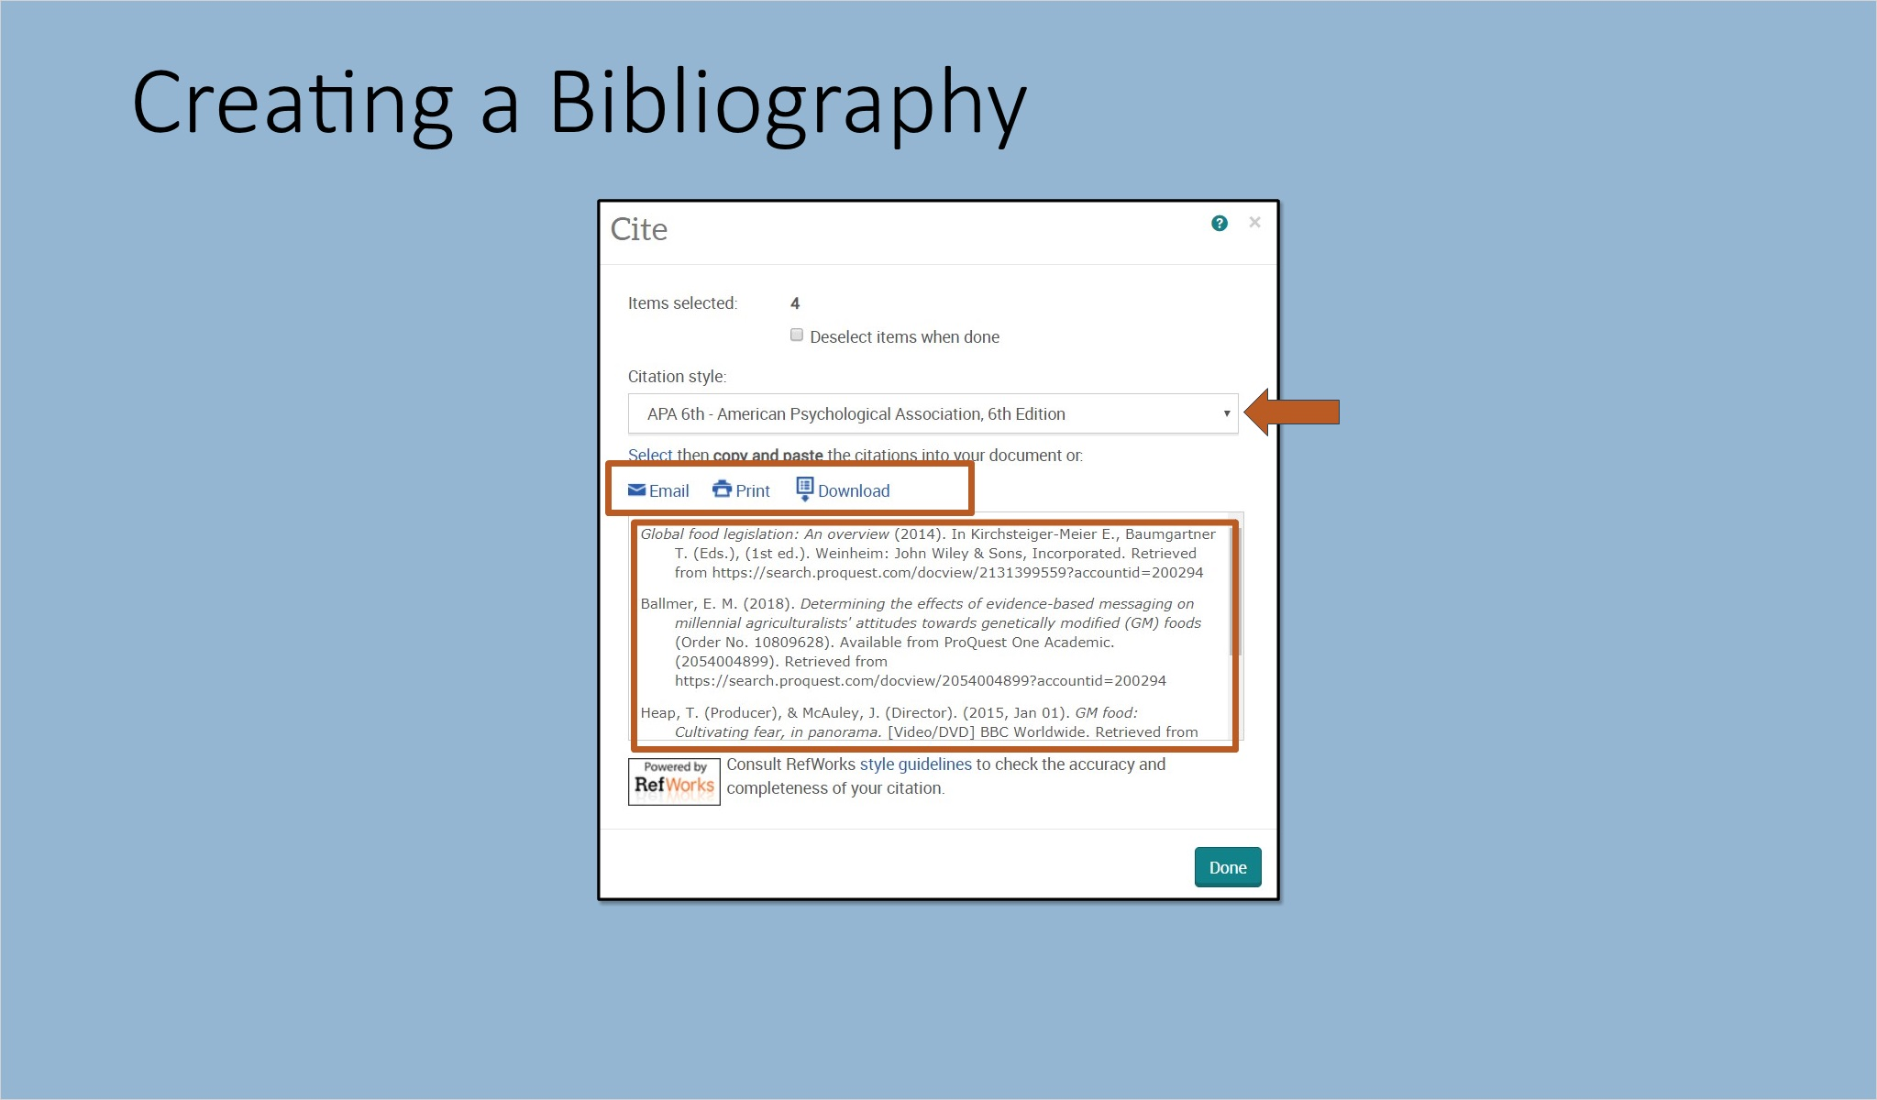

Save to RefWorks (Slide Layer)
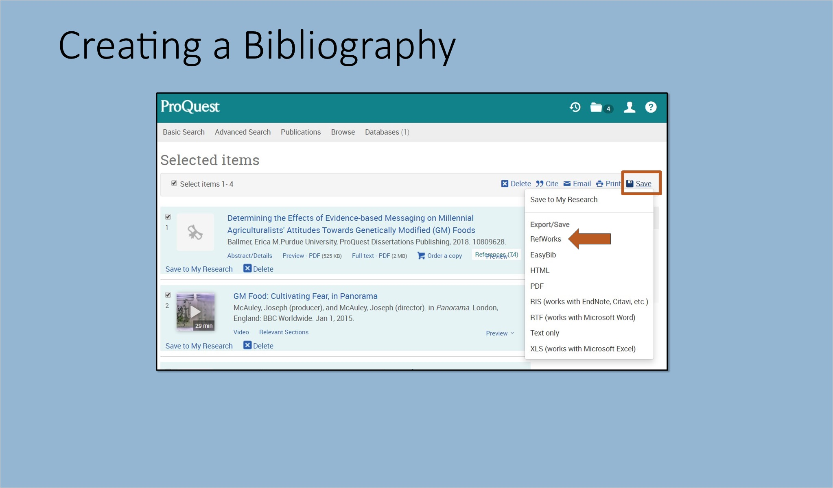

1.10 Summary
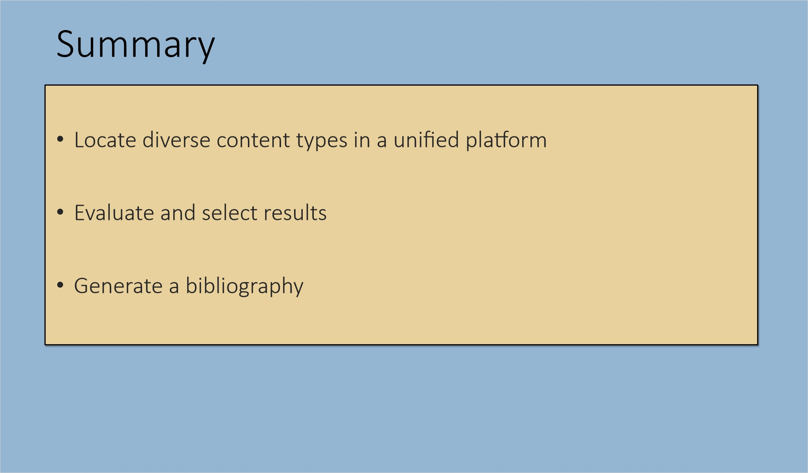
Notes:
You are now able to utilize one search to find varied content types, assess results and compile a bibliography using the ProQuest One Academic platform.

1.11 More Resources
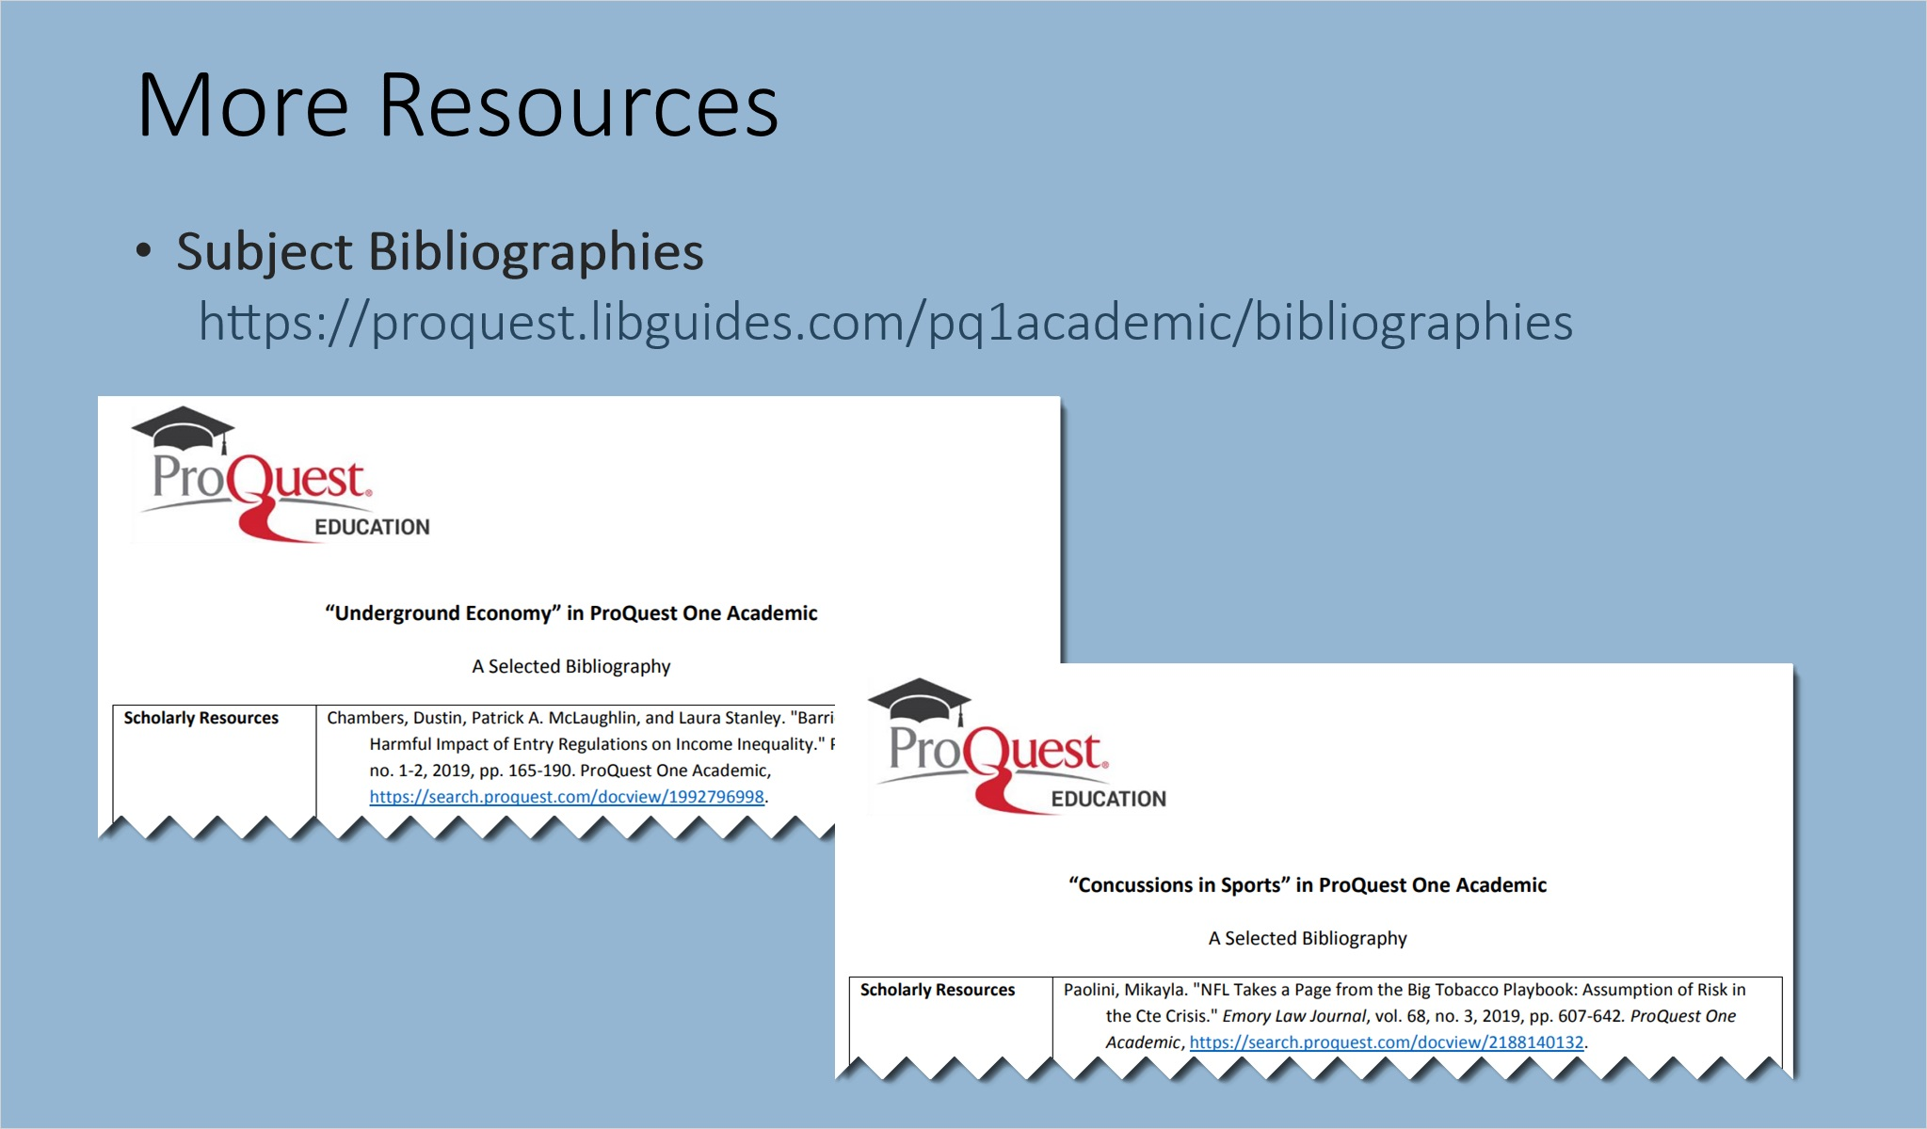
Notes:
The ProQuest One Academic LibGuide contains Subject Bibliographies covering a wide variety of topics that can be used as instruction examples or to generate research ideas.

1.12 Thank you!
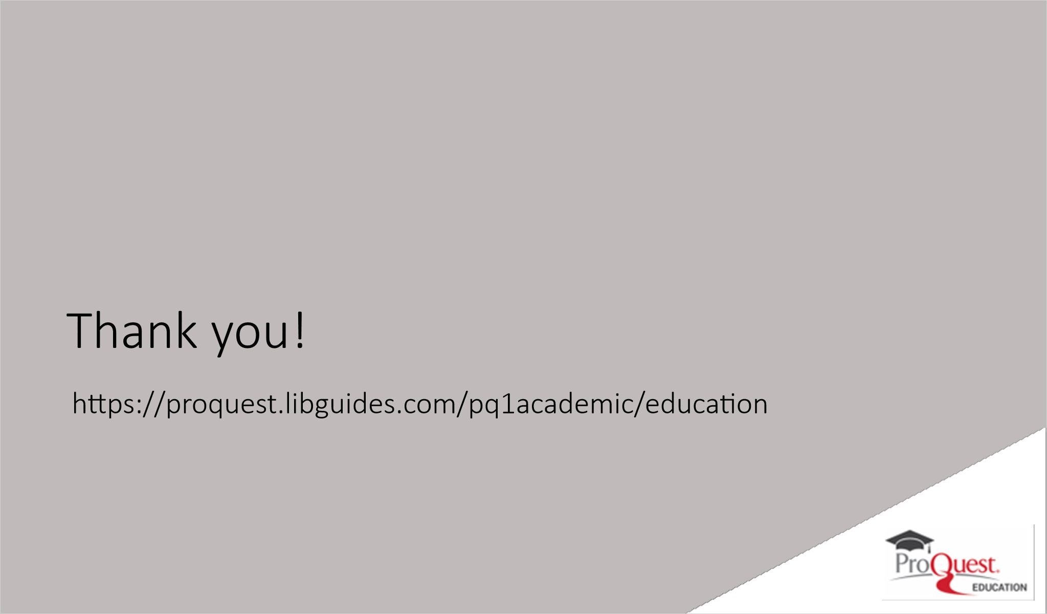
Notes:
Thank you for attending ProQuest One Academic From Search to Bibliography. To learn more, visit the ProQuest One Academic LibGuide Product Education page for additional education resources including a more in-depth PowerPoint and recorded training.

1.13 Copyright


