Creating Custom Login URLs

1. Creating Custom Login URLs

1.1 Introduction
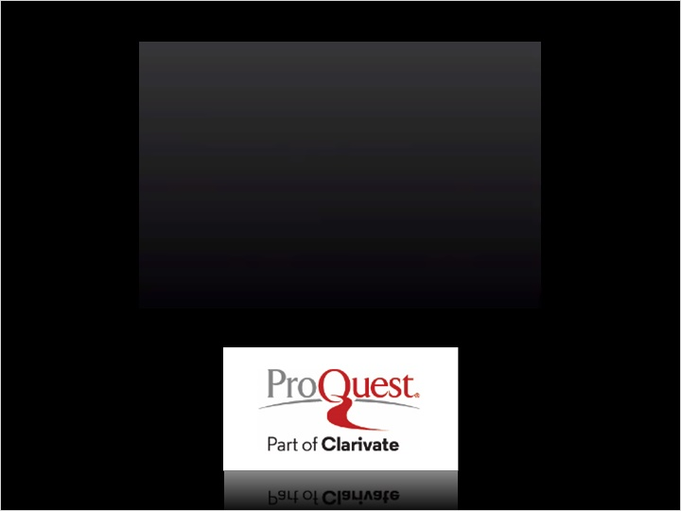
Notes:

1.2 Creating Custom Login URLs
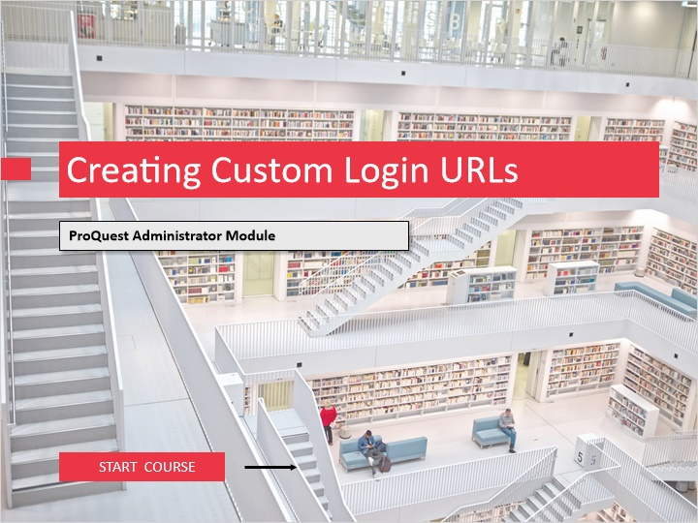
Notes:
Welcome to this session, “Creating Custom Login URLs”. Administrators may design and implement custom login URLs for the ProQuest platform using the ProQuest Administrator Module, or the “PAM”. An administrator login and password are created at the time your ProQuest account is set up. If you do not remember your login and password or need to request access to an account, please contact ProQuest Customer Service, at customerservice@proquest.com.

To begin, click on the START COURSE button.

1.3 Objectives
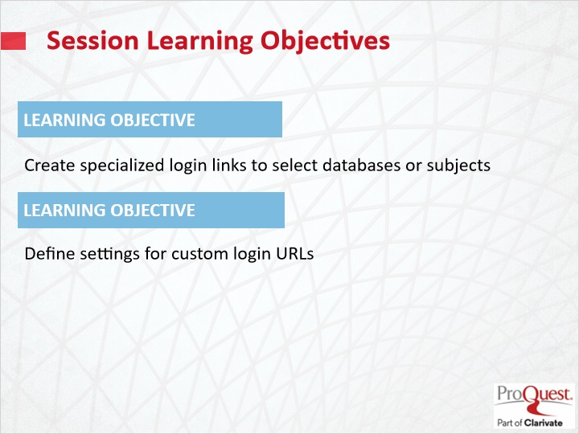
Notes:
The learning objectives for this session are

Create specialized login links to select databases or subjects.
Define settings for custom login URLs.

A note about this session:

During this session, you will learn how to use the ProQuest Administrator Module to create custom ProQuest platform login links to a database or combination of databases, as well as to content by database subject level. You will also learn how to modify certain interface settings for users of these links.

For example, you can create a customized link for Hispanic users who want to search selected Spanish newspaper databases, setting the default language to Spanish and the default search set as Publications Search. You can create a second link for others with the default search set as Basic Search. Users can then select the link they want, and open ProQuest with the desired settings. These links can be used to build a custom database menu on your library web site, add shortcuts to your computer desktops, or enhance your Favorites menus. Login links customized by bundling certain databases focused on interests of users can help increase traffic and ProQuest database usage.

1.4 Access ProQuest Administrator Module
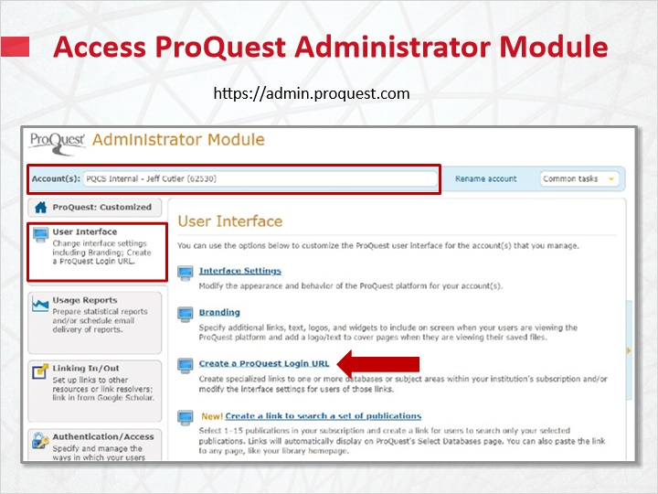
Notes:
To begin, login to the ProQuest Administrator Module at admin.proquest.com.

If you are responsible for administering more than one account, select the account you wish to create a URL for from the Accounts menu at the top of the page.

Click the link labeled User Interface at the top left of the screen, then choose Create a ProQuest Login URL.

1.5 Select Databases or Subjects
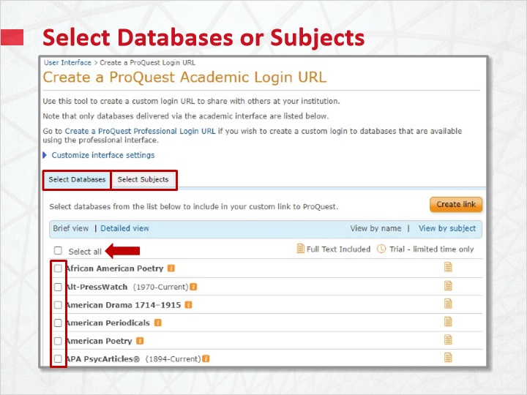
Notes:
From the Select Databases page, choose a single database or multiple databases to add to your login URL. There is also an option to include all databases as selected by default.

Or, use the Select Subjects tab to create a URL encompassing databases at the subject level. Subject levels, like Business, History, Social Science, Health and Medicine and more, are predefined by ProQuest.

The custom login URLs default to locally selected interface settings for Interface Language, Start Users On page, and whether to hide or show trial databases, for all of your ProQuest platform resources. These general settings are selected in the ProQuest Administrator Module User Interface – Interface Settings page.

You can override these general settings when you create a custom login URL. Before you create the link, click Customize interface settings at the top of the Create a ProQuest Academic Login page and adjust it according to your needs for each link you create.

Select Databases or Subjects 1 (Slide Layer)
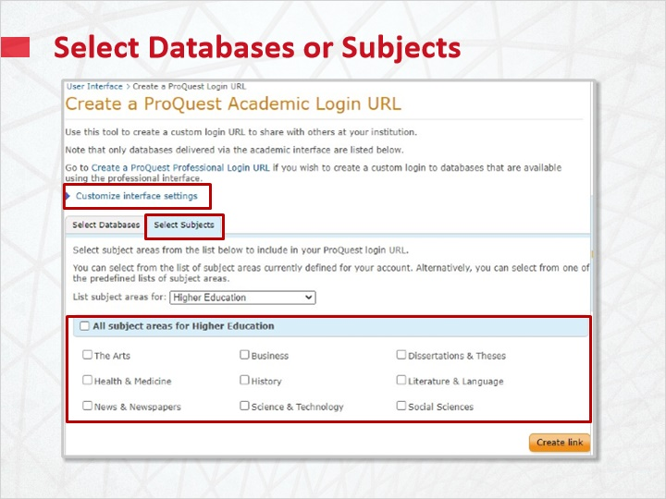

1.6 Customize Interface Settings for URL
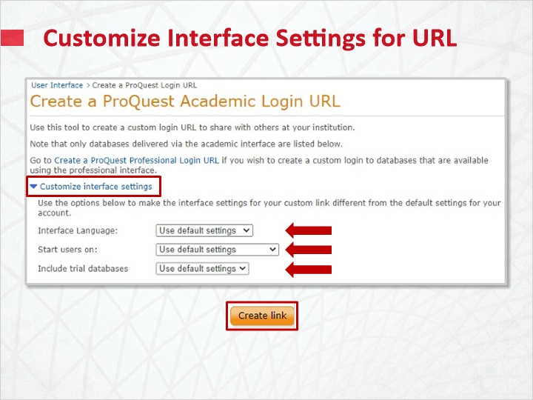
Notes:
You may adjust default Interface Language, or choose to Start users on specific search pages, namely the Basic, Advanced, Command, Publications search pages, or the Database Selection page. You may additionally choose whether to Include trial databases you may be using. When satisfied with your selections, click Create link to generate the URL.

1.7 The Custom Login URL
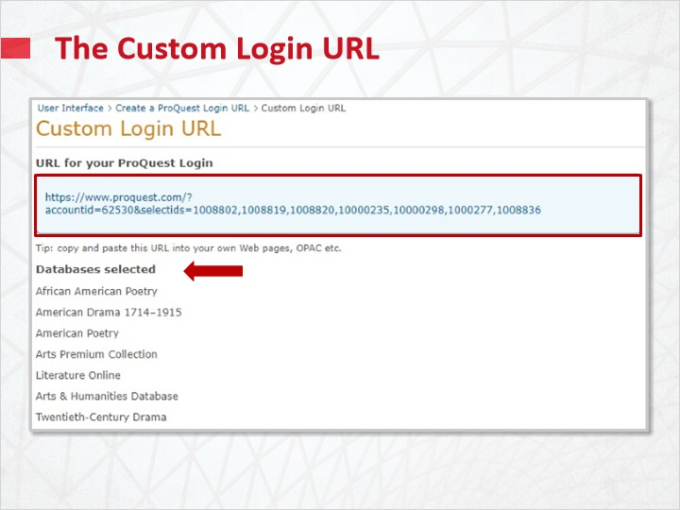
Notes:
The PAM will generate the URL for your ProQuest Login. A list of selected databases or subjects will appear below.

From there, simply copy and paste the link for use in your documents, web pages, or OPAC.

1.8 Test Your Knowledge
(Pick One, 10 points, unlimited attempts permitted)
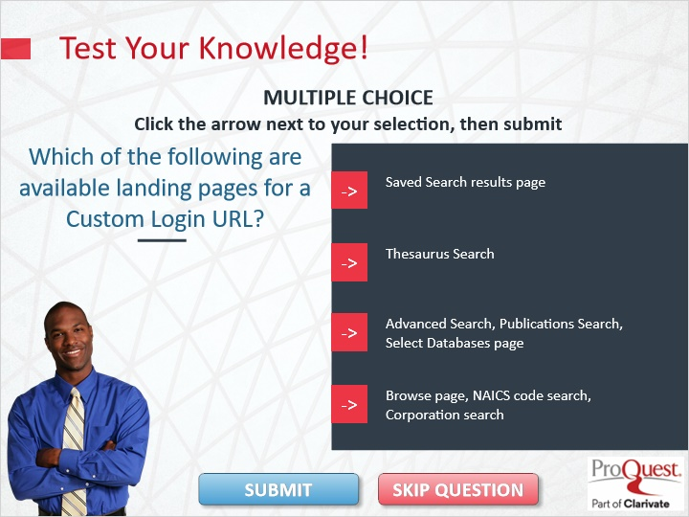
Correct | Choice | Feedback
 | Choice A | The correct answer is Advanced Search, Publications Search, Select Databases page
 | Choice B | The correct answer is Advanced Search, Publications Search, Select Databases page
X | Choice C | Congratulations!
 | Choice D | The correct answer is Advanced Search, Publications Search, Select Databases page

Notes:
Test Your Knowledge!

Click the arrow next to your selection, then submit to check your answer.

Which of the following are available landing pages for a Custom Login URL?

Incorrect. The correct answer is Advanced Search, Publications Search, Select Databases page. Press continue to move on.

That’s correct. Congratulations! Press Continue to move ahead.

1.9 Summary
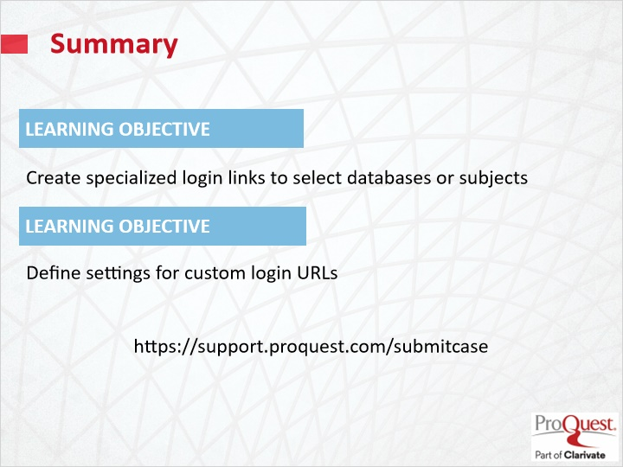
Notes:
This session has covered the following learning objectives

Create specialized login links to select databases or subjects.
Define settings for custom login URLs.

Custom login link creation is available for ProQuest platform databases. For technical support, or for custom login links to other resources such as ProQuest Congressional, Statistical, Legislative Insight, History Vault, and Government Periodicals Index, please contact ProQuest Technical Support at https://support.proquest.com/submitcase.

1.10 Thank you!
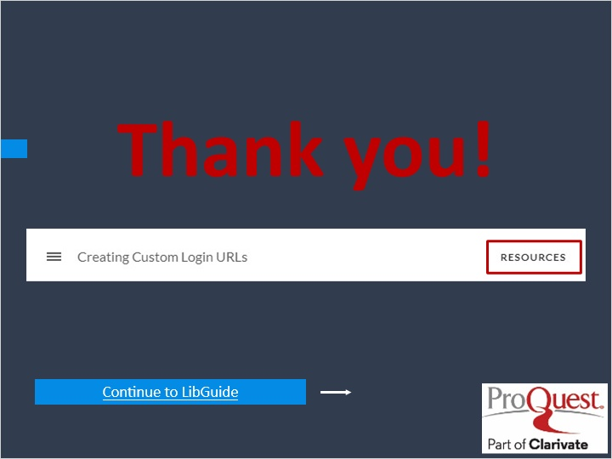
Notes:
This concludes this session. Thank you for joining! To learn more, please click on the Resources link, as illustrated, in the upper right corner of this session player, or visit our ProQuest Platform LibGuide page by clicking the LibGuide link at the bottom of this screen.

1.11 Copyright
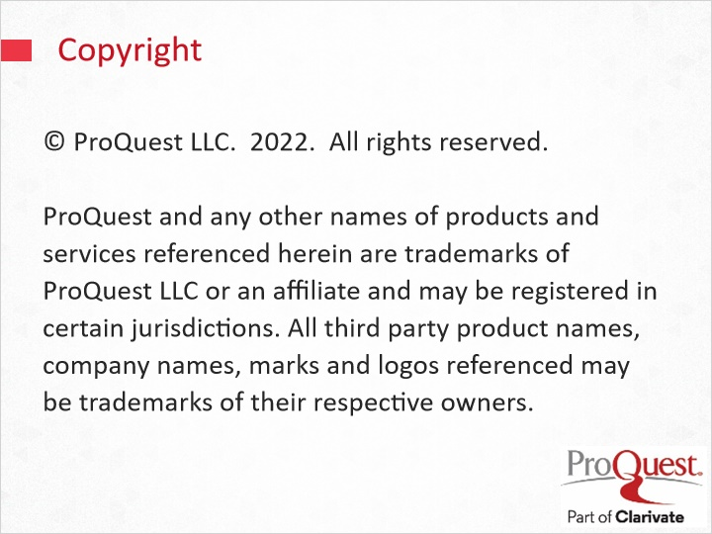
Notes:
© ProQuest LLC. 2020. All rights reserved.
ProQuest and any other names of products and services referenced herein are trademarks of ProQuest LLC or an affiliate and may be registered in certain jurisdictions. All third party product names, company names, marks and logos referenced may be trademarks of their respective owners.

