ProQuest Dissertations & Theses for Students -- Citation Connections

1. ProQuest Dissertations & Theses for Students: Citation Connections

1.1 Introduction

Notes:

1.2 ProQuest Dissertations & Theses for Students -- Citation Connections
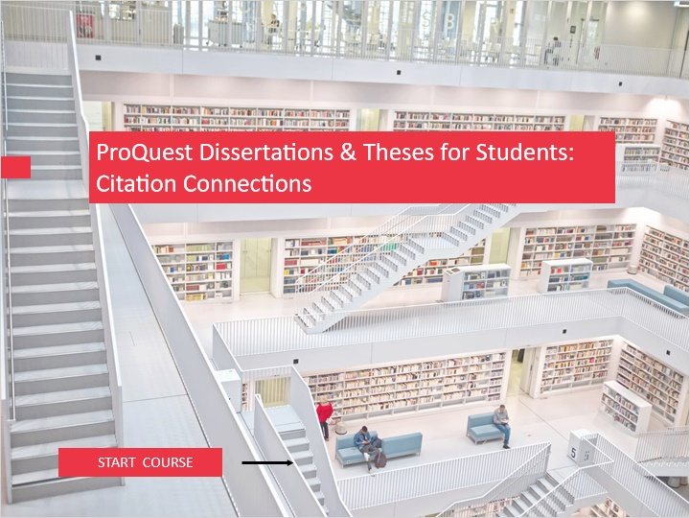
Notes:
Welcome to this session on ProQuest Dissertations and Theses for Students.
This session will show that by leveraging the rich citation data found in ProQuest Dissertations and Theses, researchers can benefit from focused pathways of discovery to build foundational knowledge on a topic, and highlight other content that can improve the diversity and comprehensiveness of the literature review. You’ll see built-in tools helping to expand your reach on information, by locating relevant documents based on the chain of citations and relevancy of the shared references.

This session assumes some familiarity with the ProQuest platform and watching the Basic and Advanced Search e-learning modules for the ProQuest platform is recommended. Please refer to the ProQuest Platform LibGuide url in the Resources.

To begin, click on the START COURSE button.

1.3 Objectives
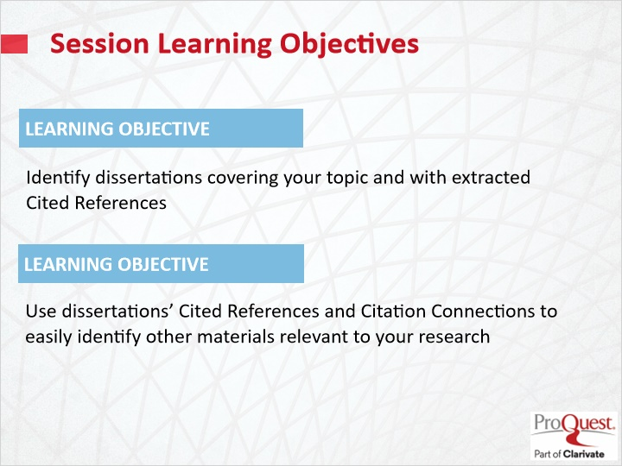
Notes:
This session has covered the following learning objectives

- Identify dissertations covering your topic and with extracted Cited References
- Use dissertations’ Cited References and Citation Connections to identify easily other materials relevant to your research

1.4 ProQuest Dissertations & Theses Global and Across all Disciplines
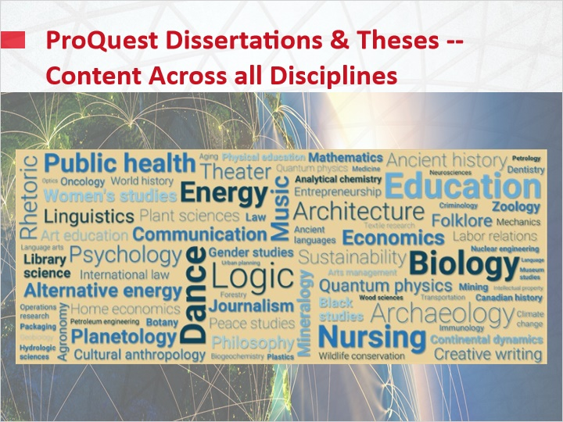
Notes:
The Dissertations and Theses content is multi-disciplinary and provides material to support all departments and disciplines.

Dissertations and theses are scholarly, reviewed work resulting from comprehensive and original research.

1.5 Introducing the new Citation Connections
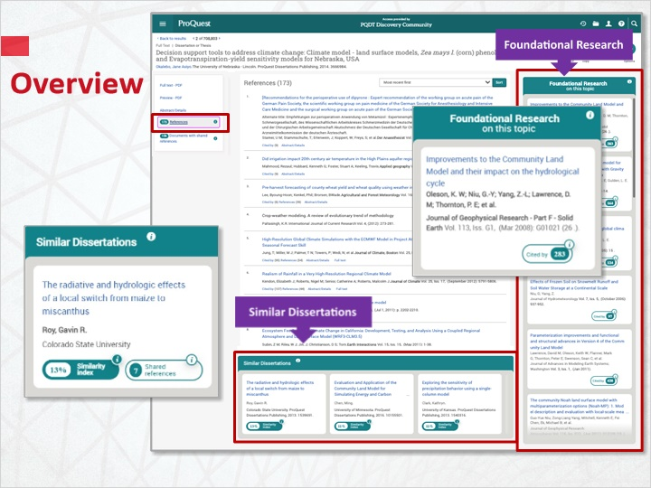
Notes:
To help focus your research path, new tools transform each dissertation or thesis with extracted cited references, into a catalyst for more efficient and effective source collection.
Dissertation citations are extracted, indexed, cross-linked, and made searchable, offering users a “ready-made” list of sources on a topic through Reference links, Cited by links, and Shared References links. Researchers of all levels can quickly build a credible source list targeted to their specific topic.
In a document with extracted references, Citation Connections deliver Foundational Research and Similar Dissertations.
Dynamic algorithms have been built on ProQuest’s comprehensive citation data, pulling forward works that share citation records.
They are developed on a knowledge framework that delivers new indices, making easy to establish connections to reveal insights that help users in their research tasks and direct students to influential sources on a topic.

1.6 How to identify theses with references
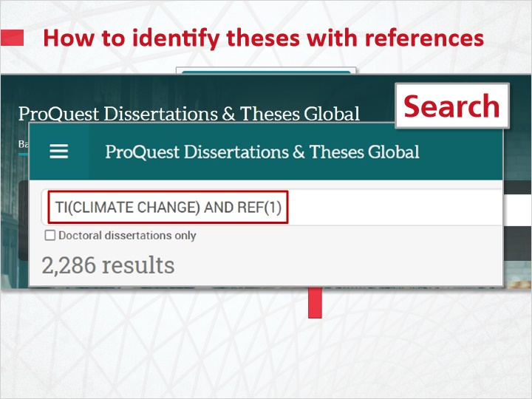
Notes:
The Citation Connections will show content only in Dissertations with extracted cited references or if there is a sufficient number of documents for your topic.
There are several ways to identify dissertations with extracted cited references, with the Search, in the Results page and in the document view.
A new Limiter is being introduced, that allows extracting only the documents with indexed references for your topic.
Alternatively you can add “AND REF(1)” to your search, so results will include documents that have at least one reference.
For example, to search for dissertations and theses related to Climate Change, the search could be, CLIMATE CHANGE in the Title AND REF(1).
When viewing search results, if a document has extracted references, there will be a References link below the title of the document, also indicating the number of references.
In the document view there will be a References tab on the left navigation pane.

Identify theses with references in the results page (Slide Layer)
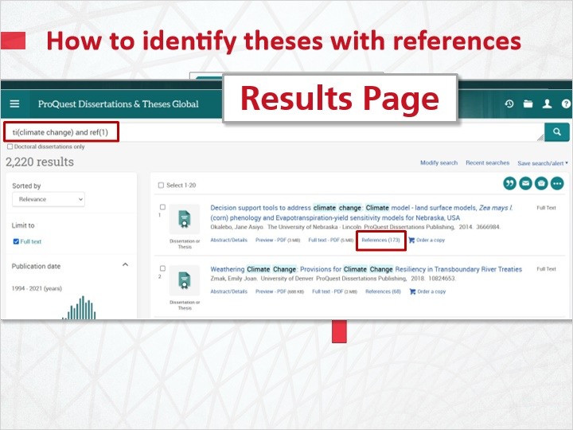

Display the cited references in Document view (Slide Layer)
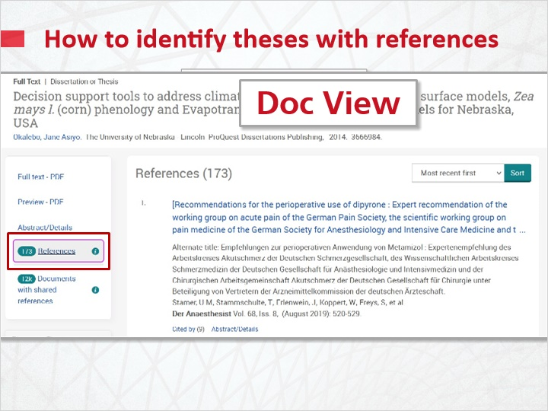

1.7 Foundational research panel
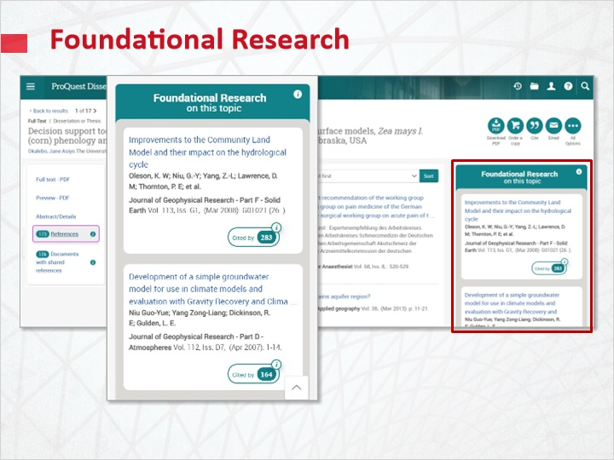
Notes:
In the Document view, The FOUNDATIONAL RESEARCH Allows researchers to efficiently focus on what is most relevant to their field, by monitoring citation frequency and delivering ground research throughout Journal Articles, Books, Dissertations and more.
Foundational Research on this topic is a collection of core research related to the topic of the seed document displayed on this page. This collection can be useful when building a foundational understanding of a topic or when selecting a topic for a research project.
The Seed document in this context is the dissertation displayed on this page that is used as the 'seed' of a computational framework to identify other sources related to the topic. The seed document is used to surface relevant items in Similar Dissertations and Foundational Research.
Some more examples in the panel show some documents with very high numbers in the Cited by mark, which the definition explains is the number of documents in ProQuest databases that have cited this source. As highly cited documents these are definitely worth reviewing literature.

Foundational research samples and explanation (Slide Layer)
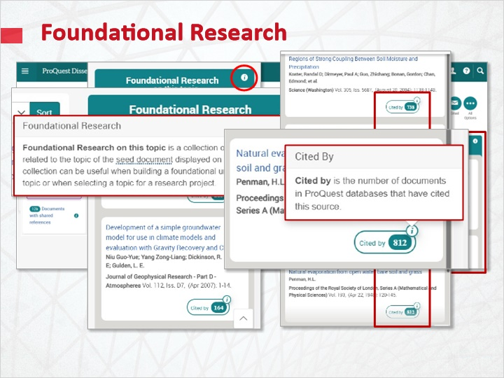

1.8 Similar Dissertations
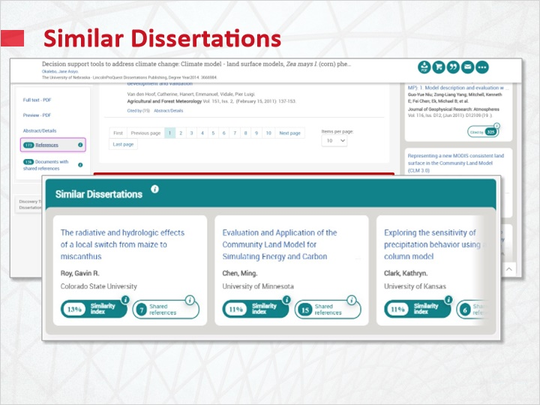
Notes:
SIMILAR DISSERTATIONS Provides researchers with a targeted way of understanding previously generated graduate research on a topic by delivering a selection of dissertations and theses based on the Similarity Index of citations.
Within the panel, additional detailed information is provided for each of the adopted parameters .
Similar dissertations: Identify other dissertations that have been written on this topic. Similar Dissertations is a collection of dissertations with research closely aligned with the seed document displayed on this page.
Seed document in this context is the dissertation displayed on this page, which is used as the 'seed' of a computational framework to identify other sources related to the topic. The seed document is used to surface relevant items in Similar Dissertations and Foundational Research.
The Similarity Index is used to rank the collection of Similar Dissertations by the degree of relationship to the topic of the seed document displayed on this page. The closer the score is to 100%, the more likely this dissertation is about the same topic.
The Shared References are the number of references in common with the seed document displayed on this page. The more references in common, the more likely the overlap in the topic of research.

Similar Dissertations details (Slide Layer)
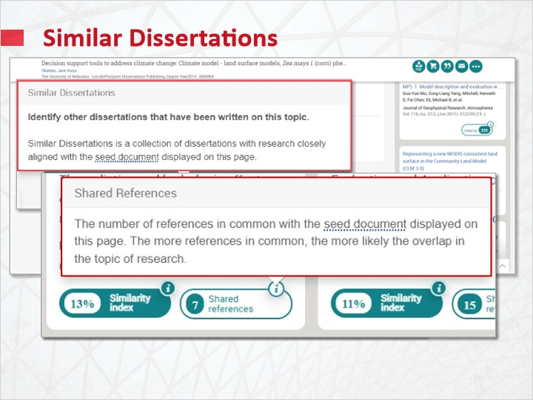

1.9 Harvesting references from citationseferences
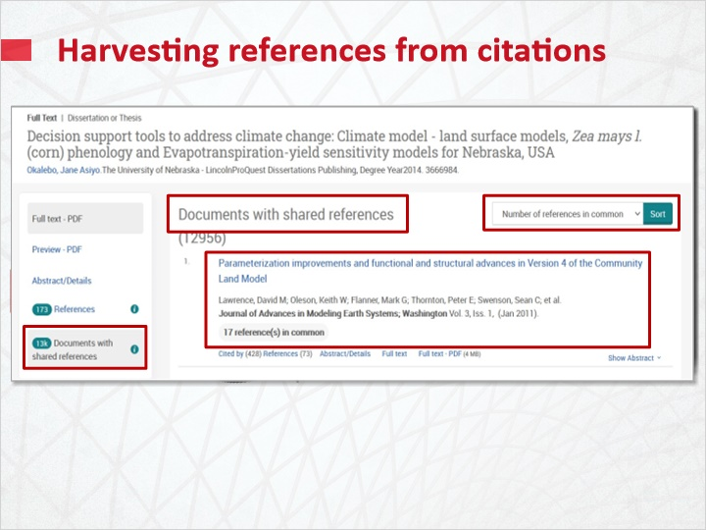
Notes:
This is an example of a dissertation with extracted references, often referred to as the "seed document", and the process of collecting more relevant references by the chain of citations and similarities that it offers.
The References tab of the seed document, shows the cited references. If the title is an active Hyperlink, the related document can be retrieved from some other ProQuest database the client subscribes to.
By the Foundational Research panel, the title in each box leads to the related document, showing its own reference links.
Similarly, by the Similar Dissertations panel. The title in each box leads to the related document, if accessible.
The link, "documents with shared references", in the seed document, will open an entire new list of references, that can be sorted by number of shared references, thus showing the most relevant at the top.

1.10 Test Your Knowledge
(Pick One, 10 points, unlimited attempts permitted)
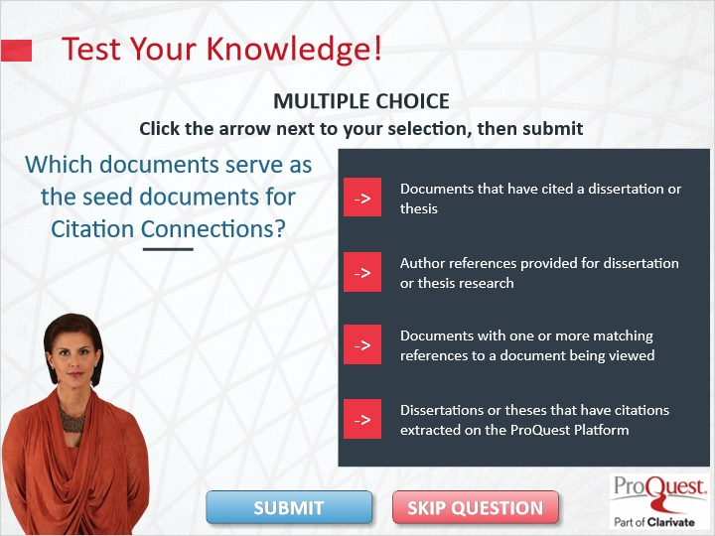
Correct | Choice | Feedback
 | Choice A | Incorrect. The correct answer is Dissertations or Theses that have citations extracted on the ProQuest Platform.
 | Choice B | Incorrect. The correct answer is Dissertations or Theses that have citations extracted on the ProQuest Platform.
 | Choice C | Incorrect. The correct answer is Dissertations or Theses that have citations extracted on the ProQuest Platform.
X | Choice D | Congratulations!

Notes: Test Your Knowledge!

Click the arrow next to your selection, then submit to check your answer?

Which documents serve as the seed documents for Citation Connections?

Incorrect. The correct answer is Dissertations or Theses that have citations extracted on the ProQuest Platform. Press continue to move on.

That’s correct. Congratulations! Press Continue to move ahead.

Thank You 1 (Slide Layer)
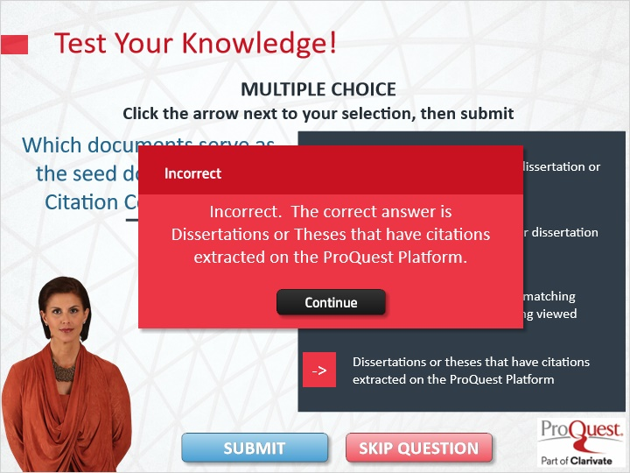

Thank You 2 (Slide Layer)

Thank You 3 (Slide Layer)
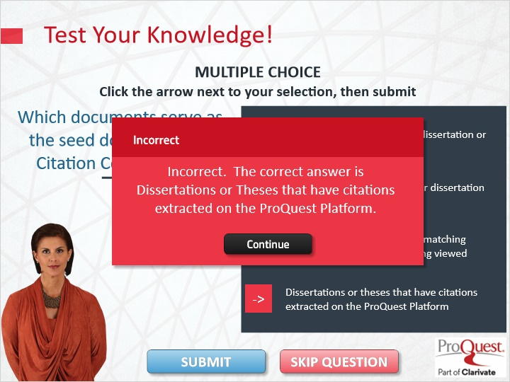

Thank You 4 (Slide Layer)
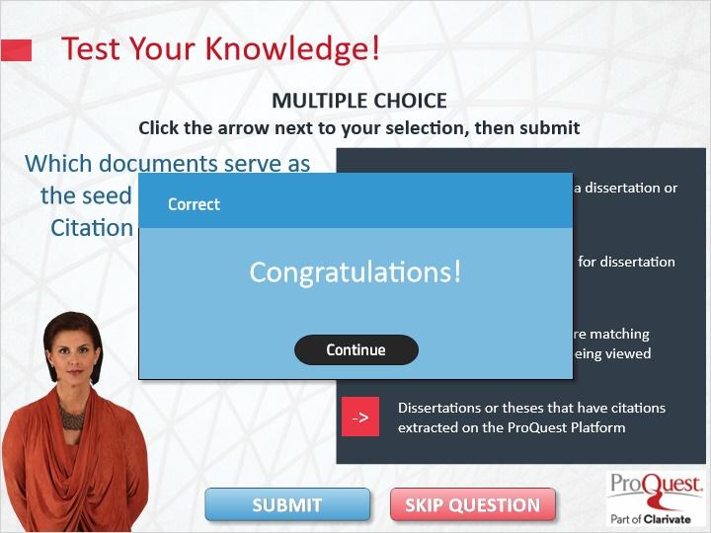

1.11 Summary
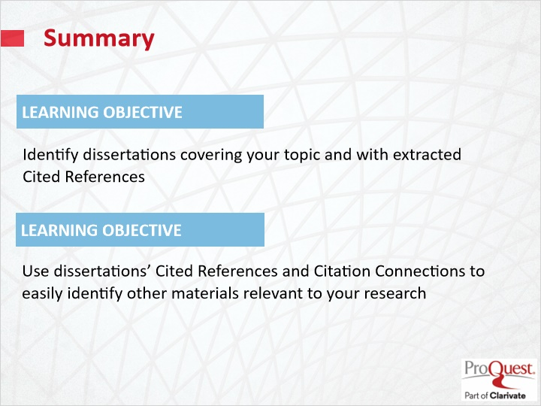
Notes: This session has covered the following learning objectives
- Identify dissertations covering your topic and with extracted Cited References
- Use dissertations’ Cited References and Citation Connections to identify easily other materials relevant to your research

1.12 Thank you!
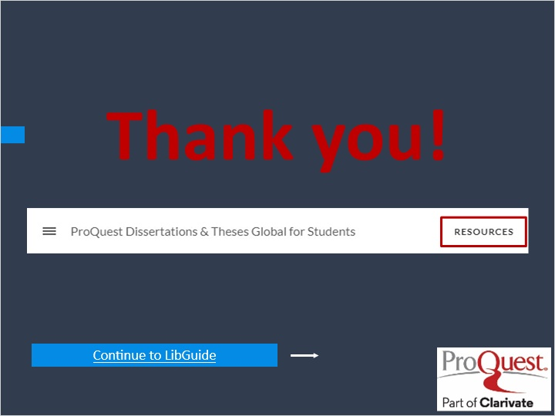
Notes: This concludes this session. Thank you for joining! To learn more, please click on the Resources link, as illustrated, in the upper right corner of this session player, or visit our ProQuest Dissertations & Theses LibGuide page by clicking the LibGuide link at the bottom of this screen.
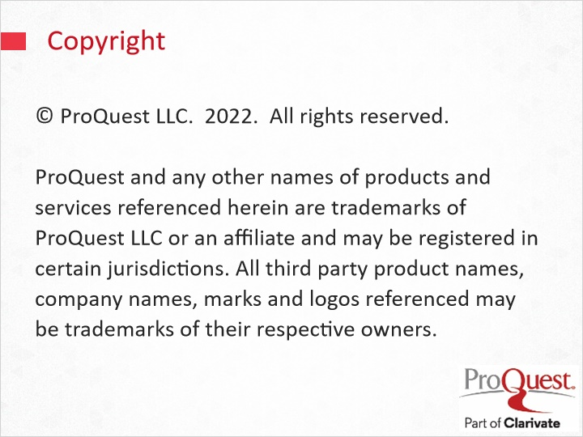
Notes: © ProQuest LLC. 2022. All rights reserved.
ProQuest and any other names of products and services referenced herein are trademarks of ProQuest LLC or an affiliate and may be registered in certain jurisdictions. All third-party product names, company names, marks and logos referenced may be trademarks of their respective owners.

