Introduction to ProQuest One Literature

1. Public / Academic Library Template

1.1 Introduction

Notes:

1.2 Introduction to ProQuest One Literature
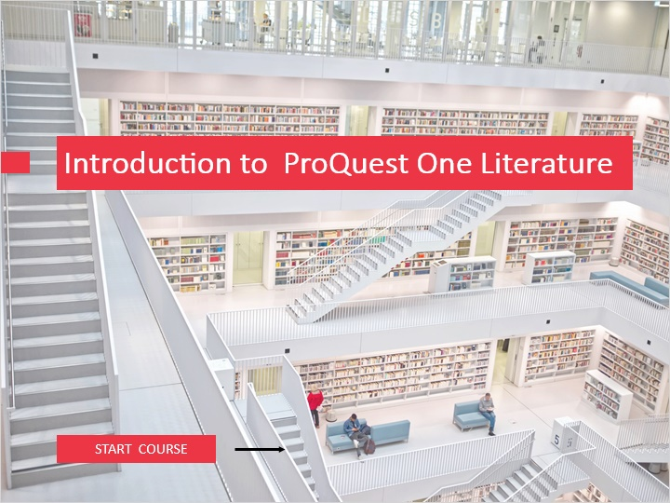
Notes:
Welcome to this learning module introducing ProQuest One Literature.

ProQuest One Literature provides an integrated search experience on this broad discipline, centered around authors, movements and works, powered by several key content types.This module will show which these content types are and the different points of access to them.
This session assumes a previous basic knowledge of the ProQuest Platform search features.

Click on the Start Course button to proceed.

1.3 Objectives
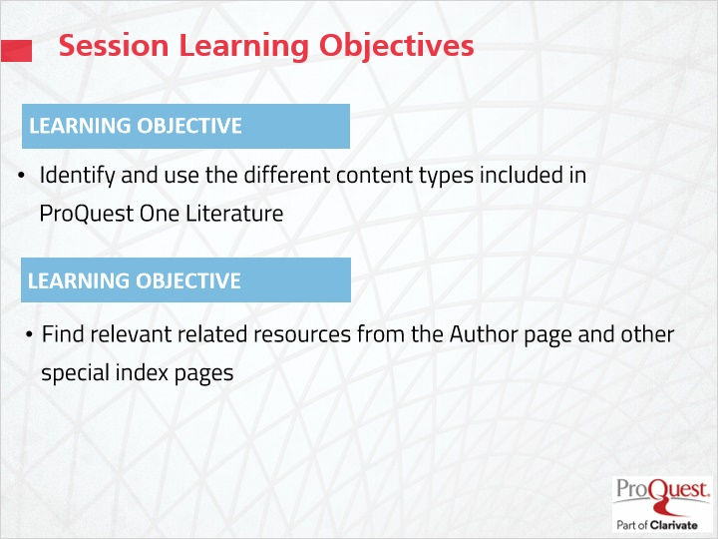
Notes:
The learning objectives for this session are

Identify and use the different content types included in ProQuest One Literature
and
Find the relevant information and sources related to an Author in the specially designed Author page and other index results pages.

1.4 The ProQuest One Literature Homepage
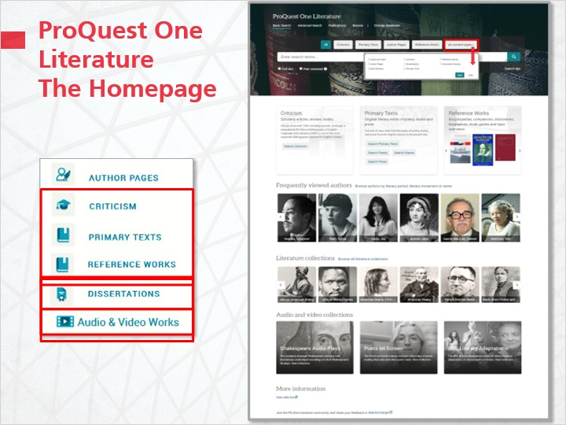
Notes:
The ProQuest One Literature Home page shows more than the Basic search level. It is an engaging introduction to the collection structure, since it provides a compelling visual overview of all the available content types, in the body of the page, along with the links to search forms and browse features at the top.
Above the Search box the different source filters allow to limit immediately the search to one content type or another.
In the Central section you can find links to searching the different content clusters in Advanced Search
The core of ProQuest One Literature’s content is a library of over 500,000 primary works of poetry, drama and prose dating from the 8th Century A.D. to the present day.
The Annual Bibliography of English Language and Literature index of articles, monographs and dissertations from 1920 to present, is a comprehensive library of literary criticism, enhanced by over 1,200 current Journals in Full-Text.
A large collection of reference resources, which includes over 8,000 specially commissioned Biographies + 1,500 Bibliographies, plus essential encyclopedias and companions covering a range of genres and national literatures.
The next section in the page is a carousel with a selection of notable authors.
The following carousel is an easy access to the over literature collections of the Primary texts, now including African, Asian, Latino-American centered, and the German language collections, increasing the global coverage.
ProQuest One Literature also includes multimedia content which is partly highlighted in this section. - The BBC edition of the complete Shakespeare’s works audio recordings. – Nearly 900 video clips of poets reading their own and others’ works. – 166 of the renowned BBC productions of famous classic literary works.
Finally - At the bottom of the page you can download an updated excel title list of ALL the different sources available in ProQuest One Literature, including the Primary & Reference Texts and the Scholarly criticism periodicals.
To all the classic content types included in Literature Online, ProQuest One now adds more content from Dissertations, videos from Alexander Street, and ebooks from Ebook Central, embedded in the major content types.

1.5 the new Browse Menus
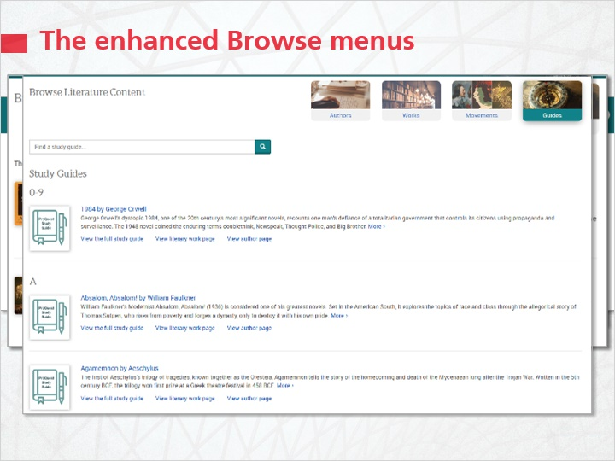
Notes:
The Browse option in ProQuest One Literature allows exploring all the content in a very easy way.
The main menu shows the 4 sections:
The Author section allows exploring the Authors by various criteria, alphabetical, by literary period or movement
The Works section arranges the literary works around the over 30 global collections,
The Movement section is the point of easy access to specially designed pages on over 100 Literary Movements, from Acmeism to ’Writers of the 1930s’
The Guides section gives access to around 230 Study Guides on major literature works, from 1984 to Wuthering Heights.

1.6 Searching Authors and the Author Page
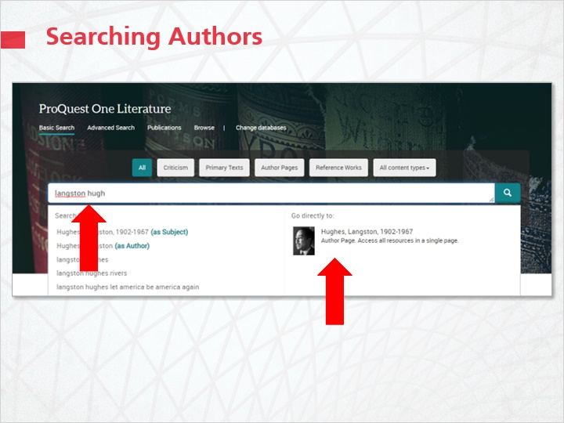
Notes:
The majority of the searches in ProQuest One Literature start from an author name.
There are several ways to search for an author name.
From the home page: enter the author name in the box. In the suggested terms appearing below as you type the name, you will see the relevant author page appearing on the right. You can go straight to that link.
Alternatively, if you select the Author Pages filter, the results page will show a list of authors. At the top you’ll find the relevant Author Page.
You can also browse the authors by Literary Movement, Period, or from the Alpha list.

Author Page from Content Type filter (Slide Layer)
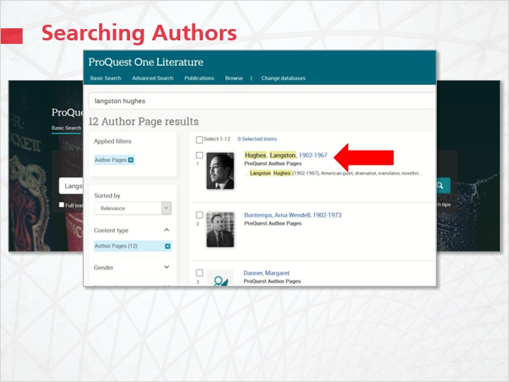

Author Pages from Browse (Slide Layer)
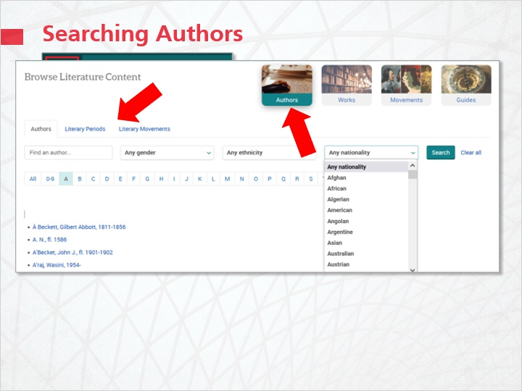

1.7 The Author Page
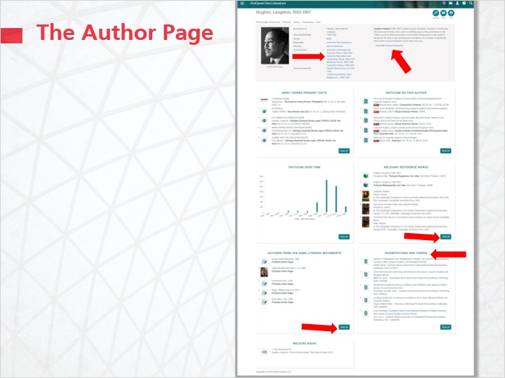
Notes:
The Author Page assembles together in one place all the information available in ProQuest One Literature on an author.
It will show first the essential biographic information of the author, the indexing, including the literary movement, which he or she is part of, and a link to a more extended biography and bibliography.
In the lower section it will list all the content relevant for that author in separate boxes, making easy to spot and reach the different types of sources,
In each box you’ll see also a button to go to the extended list of each resource, when there are more results.
Notice the additional content: Dissertations and multimedia content such as audio files and video.

1.8 Searching on All Content Types
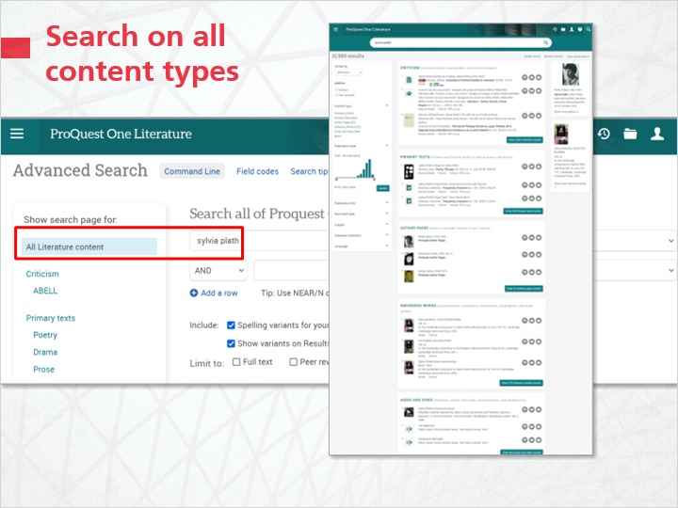
Notes:
When searching a topic in all the sources, whether in Basic Search, or Advanced Search,
ProQuest One Literature will present another Results index page, the Main results page.

1.9 The Main Results Page
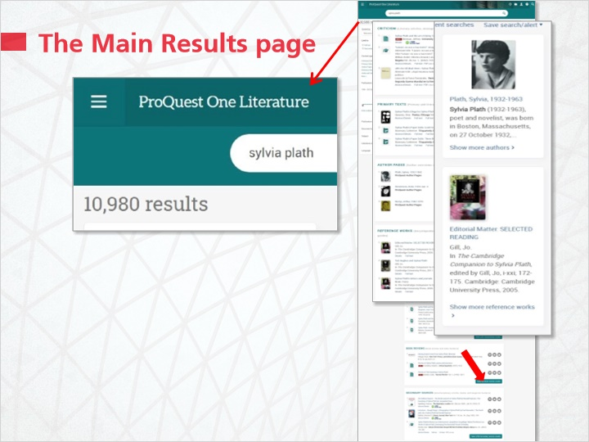
Notes:
The Main results page, arranges the results of a topic by the main content types, making it easier to select the more relevant sources. So you will find the results arranged by: Criticism and Primary Texts, Author pages and Reference Works, Audio and Video files and Dissertations, Book Reviews and Secondary Sources.
Books, and the Author page, are presented in prominent position on the right.

1.10 The Literary Movement page
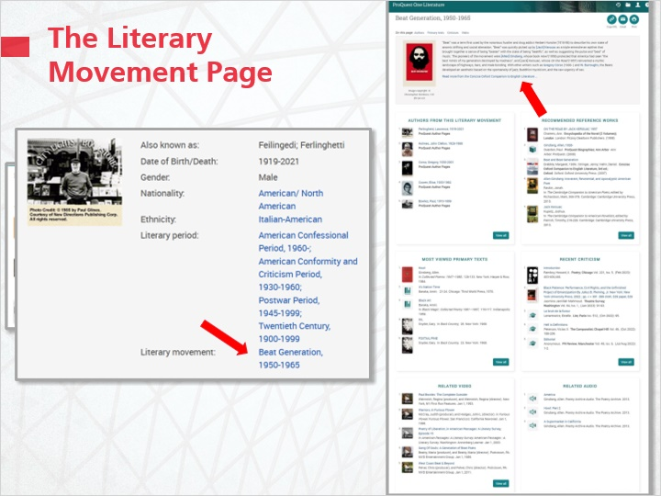
Notes:
ProQuest One Literature finally offers another specially designed results page, the Literary Movement page.
This can be reached from the Browse specific list in the Browse section, or from the Author page profile.
Designed in a way similar to the other special pages,
this one will present a short description of the movement, and a link to a more extended overview from the Reference works,
then will arrange the results relevant to the literary movement, in groups by content type.

1.11 Test Your Knowledge
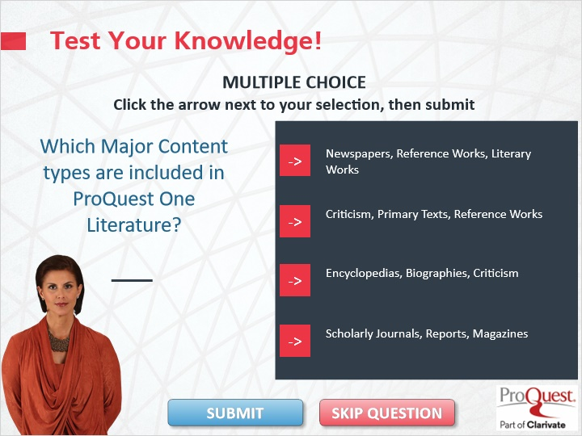
Notes:
Test Your Knowledge!

Click the arrow next to your selection, then submit to check your answer.

Which Major Content Types are included in ProQuest One Literature?

Incorrect. The correct answer is the Criticism, Primary Texts, Reference Works. Press continue to move on.

That’s correct. Congratulations! Press Continue to move ahead.

1.12 Objectives Summary
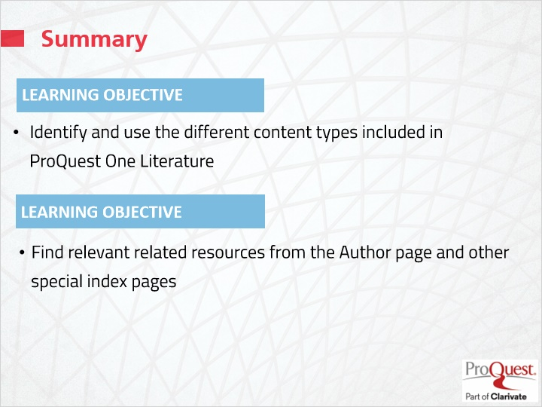
Notes:
This session has covered the following learning objectives

Identify and use the different content types included in ProQuest One Literature
and
Find the relevant information and sources related to an Author in the specially designed Author page and other index results pages.

1.13 Thank you!
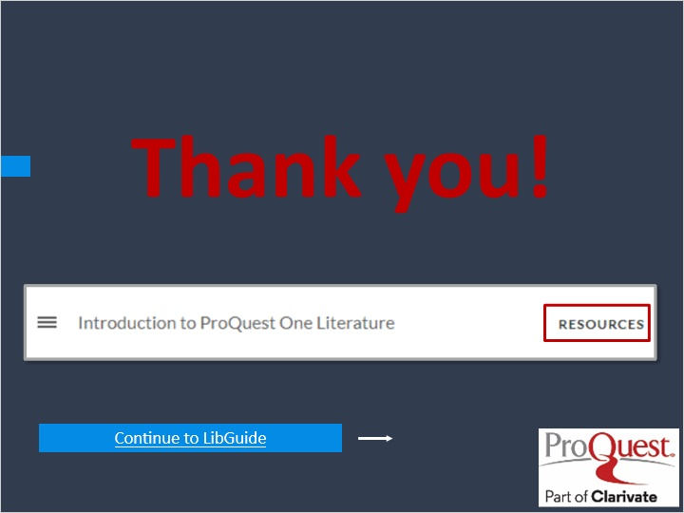
Notes:
This concludes this session. Thank you for joining! To learn more, please click on the Resources link, as illustrated, in the upper right corner of this session player, or visit our ProQuest One Literature LibGuide by clicking the LibGuide link at the bottom of this screen.

1.14 Copyright
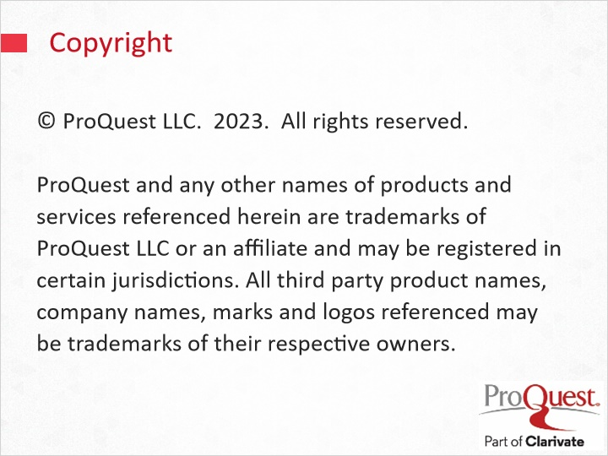
Notes:
© ProQuest LLC. 2023. All rights reserved.
ProQuest and any other names of products and services referenced herein are trademarks of ProQuest LLC or an affiliate and may be registered in certain jurisdictions. All third party product names, company names, marks and logos referenced may be trademarks of their respective owners.

