Health & Medical Collection: Advanced Search Strategies

1. Advanced Searching in Health & Medical Collection

1.1 Introduction

Notes:

1.2 Health & Medical Collection:

Advanced Search Strategies

Notes:
Welcome to the first title slide of this presentation, entitled “Advanced Searching in Health & Medical Collection”. To begin, click on the START COURSE button.

1.3 Learning Objectives
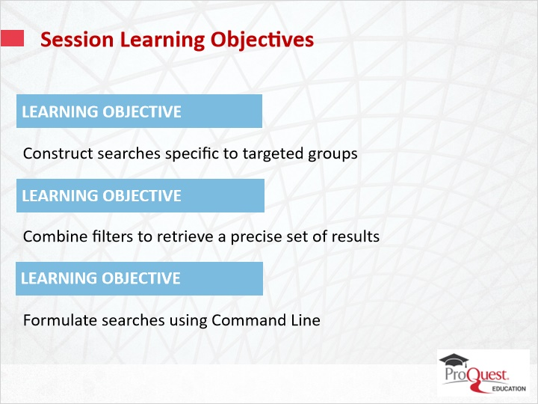
Notes:
In this session, you will learn how to:
- Construct searches specific to targeted groups
- Combine filters to retrieve a precise set of results
- Formulate searches using Command Line

1.4 Targeted Age Groups
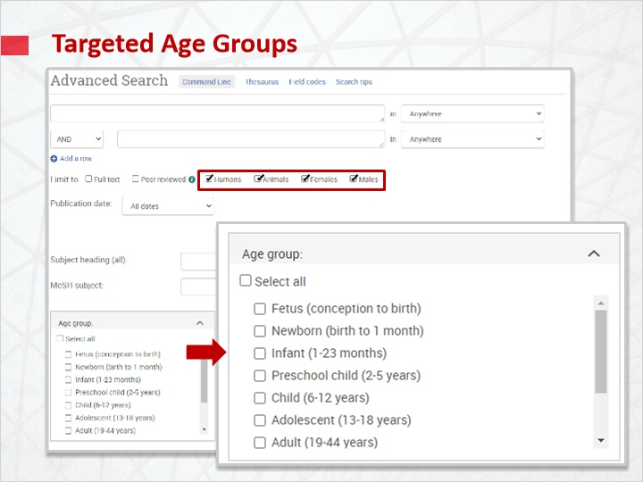
Notes:
The advanced search screen in the Health & Medical Collection includes limits that are particularly useful for targeting specific groups . These limiters allow you to limit to humans, animals, males, and females. The age group facet also allows you to target your search to specific age groups.

1.5 Age and Gender Filters
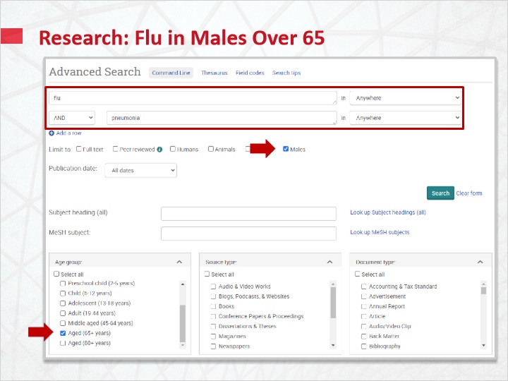
Notes:
In this example, you are looking for information about flu and pneumonia in men over 65. The male limit and the age group limits are selected in addition to adding the search terms.

1.6 Age and Gender Filters
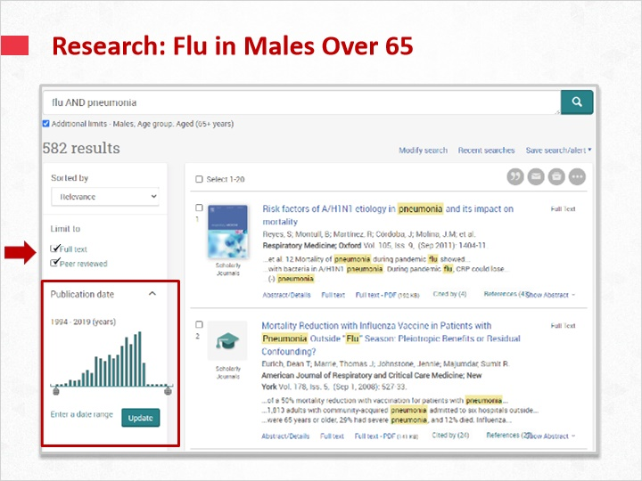
Notes:
You could further narrow this by publication date or applying the Full Text and Peer Reviewed filters.

1.7 Targeted Search Using MeSH
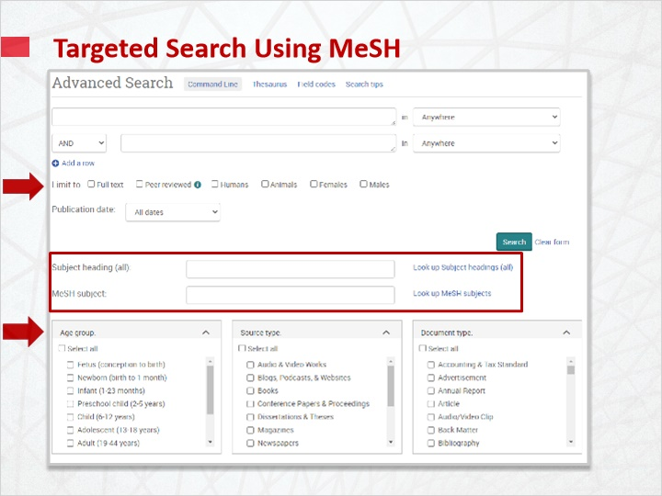
Notes:
You can also use the MeSH thesaurus or the subject headings. Using these options in combination allows you to focus your search to the specific group applicable.

1.8 MeSH Search Example
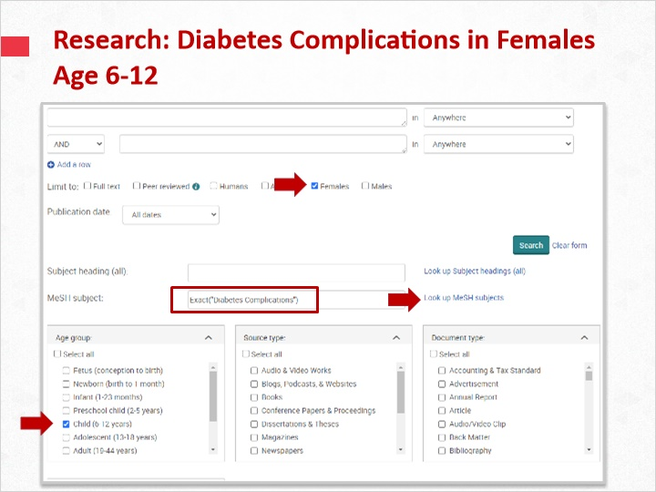
Notes:
In this example, you are looking for information about diabetes complications in female children aged 6-12. The MeSH subject heading Diabetes Complications is added using the “Look Up MeSH subjects” pop up window .

1.9 MeSH Search Example
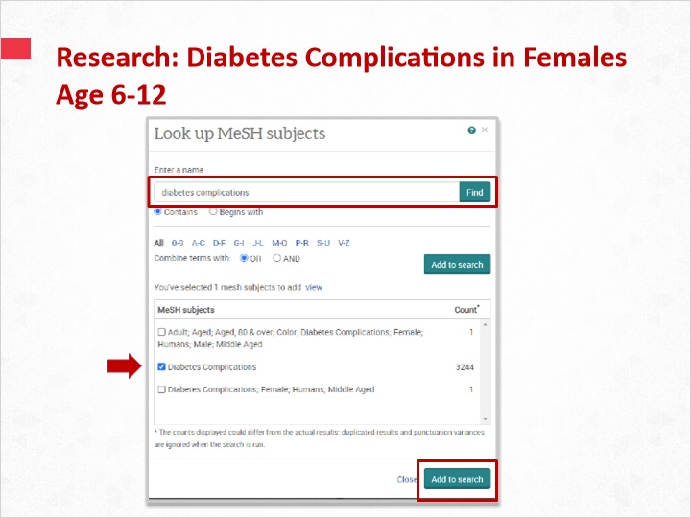
Notes:
In the MeSH pop up window, search for the term “diabetes complications” and then select all the relevant subject filters to add to the search.

1.10 MeSH Search Example
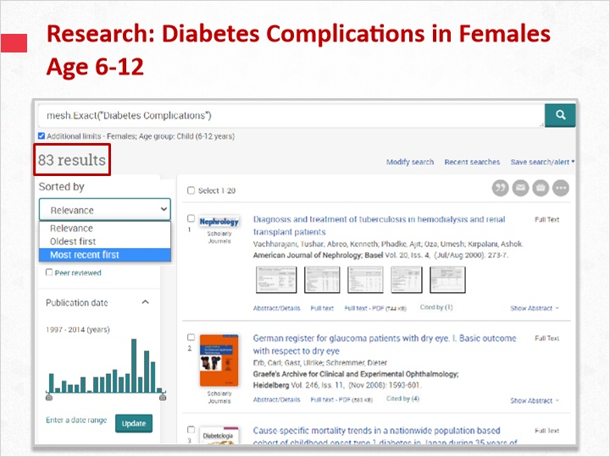
Notes:
This targeted search resulted in 83 items. You can find the most recent articles by using the Sort By drop down menu.

1.11 Targeted Content Types
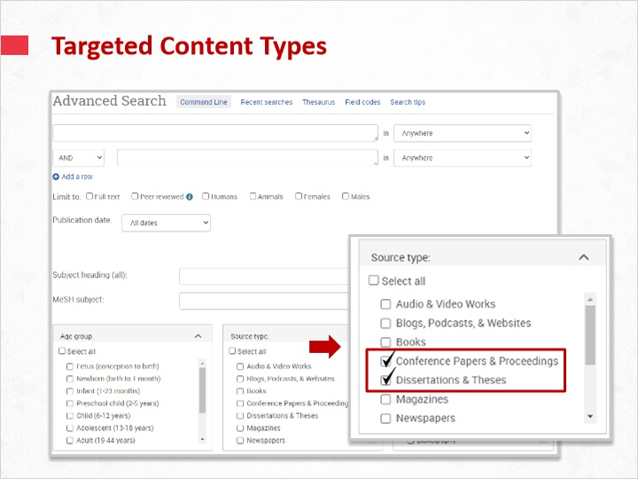
Notes:
You can also use the advanced search page to target specific content types. Using the Source Type facet, you can identify a wide range of specific content. For example, you may want primary sources such as dissertations or conference proceedings. You can also narrow down to video content.

1.12 Multiple Combined Filters
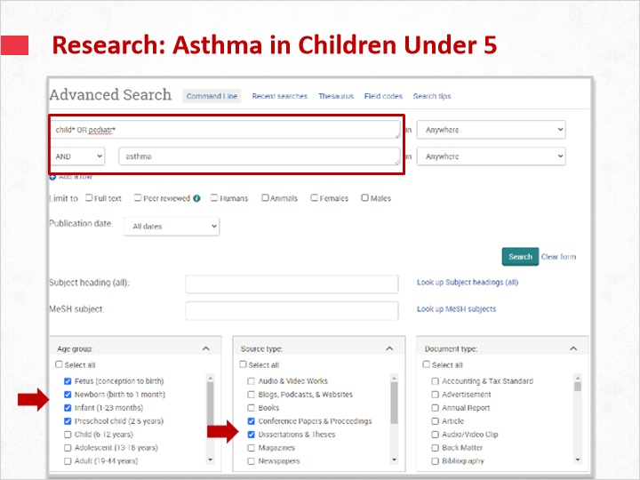
Notes:
In this search, you are looking for primary source research for children under 3 with asthma. Key words are entered into the search bars, the filters for children under 3 are selected and we also limit down to conference proceedings and dissertations & theses.

1.13 Multiple Combined Filters
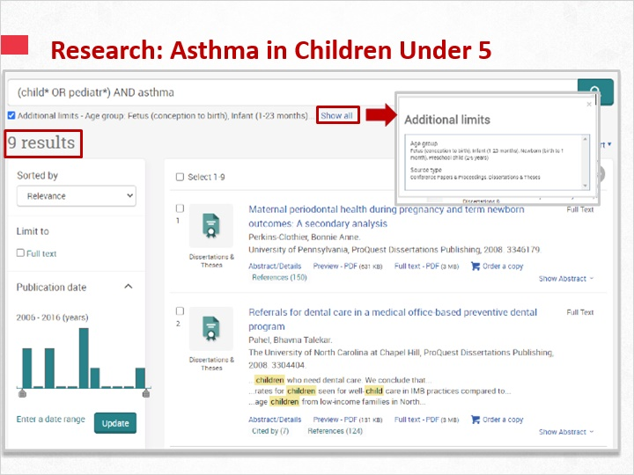
Notes:
These 9 results are a set of precise articles relevant to the search, which illustrates the power of applying search facets in combination.

1.14 Cited Publications Search
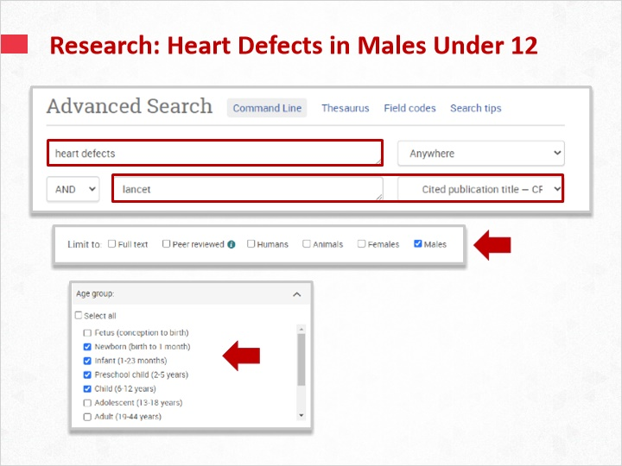
Notes:
In this second example, you are searching for journal articles about heart defects that have cited the journal, The Lancet. You only want male children under 12, so the appropriate age and gender facets are also selected.

1.15 Cited Publications Search
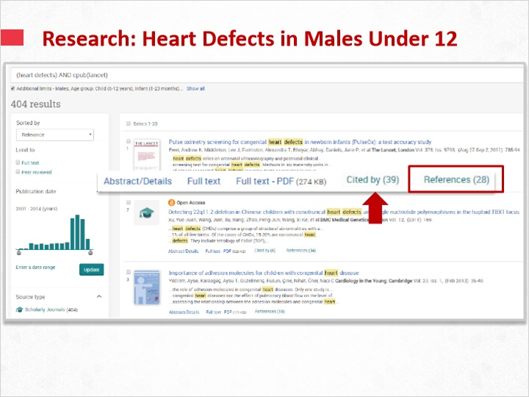
Notes:
Now you have a set of results that have cited the journal, the Lancet. You can check this by clicking on the References list of each article. The Cited By feature also showcases articles that have cited that particular article and can be used as an indicator of academic relevance.

1.16 Using Command Line
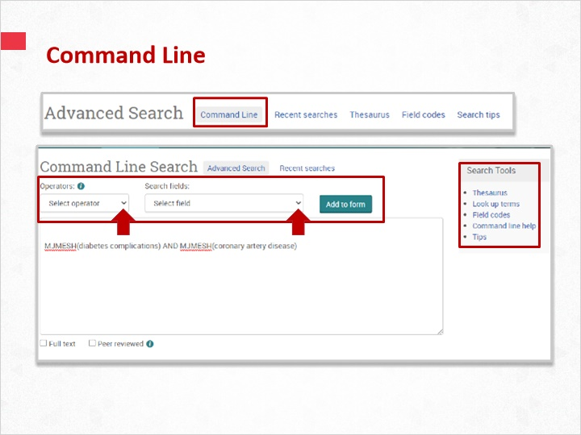
Notes:
Utilising command line search can return exact results by using specific operators and search fields to build a complex search. If you are familiar with the operators and search fields, you can type into the box. If you are not familiar, you can use the drop down menus to build your search. The search tools box gives you access to the thesaurus and field codes if needed.

1.17 Command Line Search
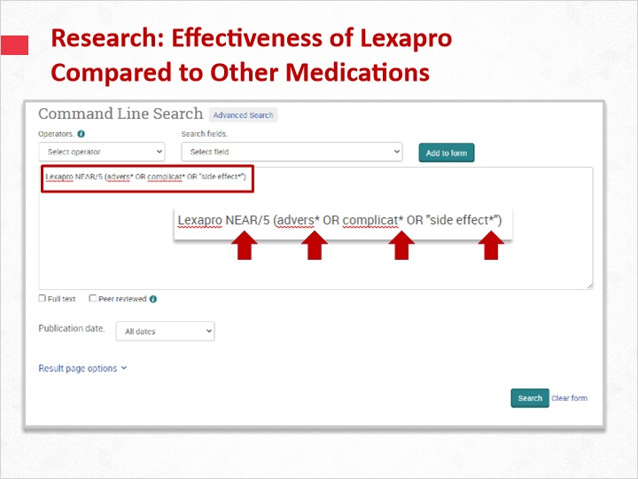
Notes:
In this example, you wish to find potential adverse effects with the medication Lexapro. Using the proximity operator (N/n), and the truncation character (*), you targeted your results for articles that mention the words “adverse” or “complications” or “side effects”, and their spelling variations, within five words of the drug name, Lexapro.

1.18 Command Line Search
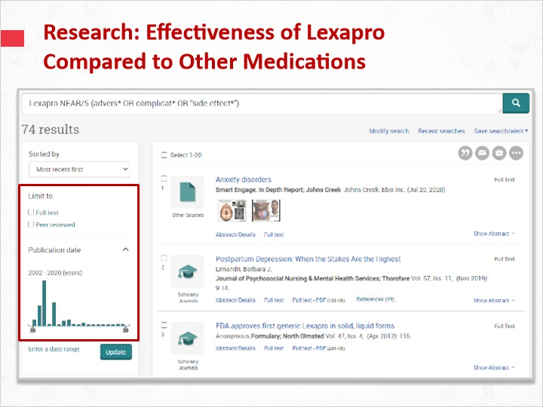
Notes:
The search results are again narrow and relevant to the search terms entered. You could further narrow this search by adding additional terms, date ranges, and more.

1.19 Test Your Knowledge
(Pick One, 10 points, unlimited attempts permitted)

Correct | Choice | Feedback
 | Choice A | The correct answer is “all the options apply”
 | Choice B | The correct answer is “all the options apply”
X | Choice C | Congratulations!
 | Choice D | The correct answer is “all the options apply”

Notes:
Test Your Knowledge!

Click the arrow next to your selection, then submit to check your answer.

How can you target your search?

The correct answer is “all the options apply”

Thank You 1 (Slide Layer)


Thank You 2 (Slide Layer)

Thank You 3 (Slide Layer)


Thank You 4 (Slide Layer)

1.20 Summary
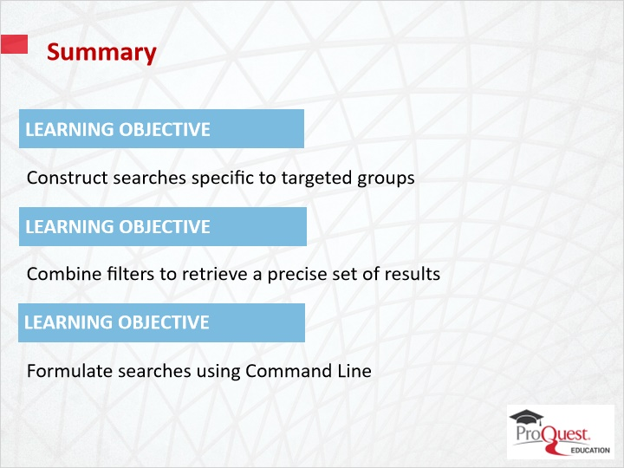
Notes:
Now you will have learned to:
Construct searches specific to targeted groups
Combine filters to retrieve a precise set of results
Formulate searches using Command Line

1.21 Thank you!
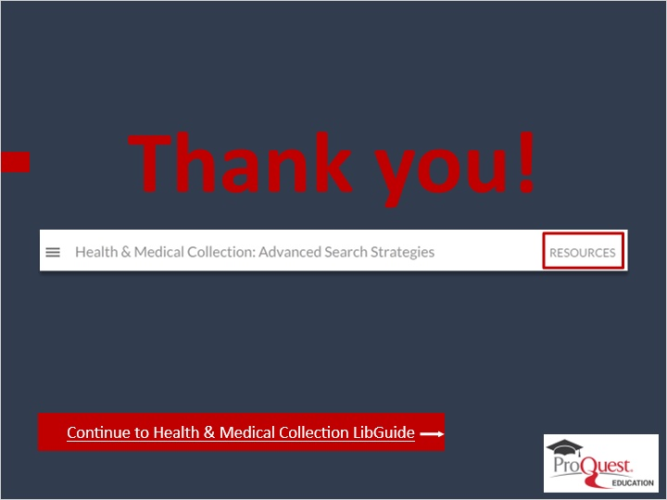
Notes:
This concludes this session. Thank you for joining! To learn more, please click on the Resources link, as illustrated, in the upper right corner of this session player, or visit our Health & Medical LibGuide page by clicking the LibGuide link at the bottom of this screen.

1.22 Copyright
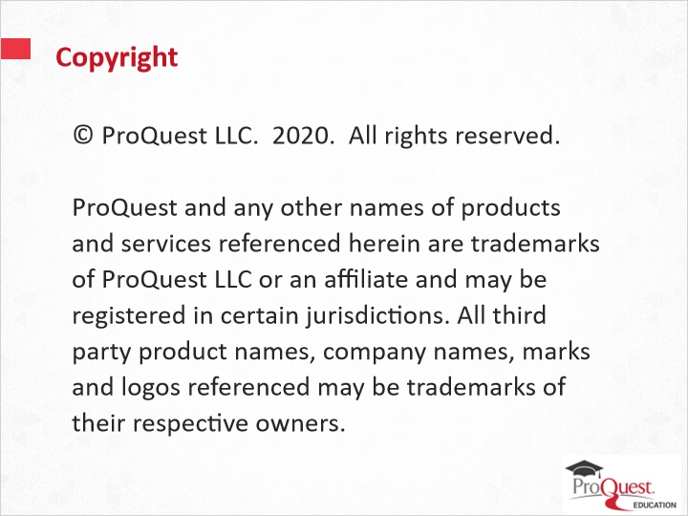
Notes:
© ProQuest LLC. 2020. All rights reserved.
ProQuest and any other names of products and services referenced herein are trademarks of ProQuest LLC or an affiliate and may be registered in certain jurisdictions. All third party product names, company names, marks and logos referenced may be trademarks of their respective owners.

