LibCentral: Usage Reports for Administrators

1. EBC_LibCentral_UsageReportsforAdministrators

1.1 Introduction
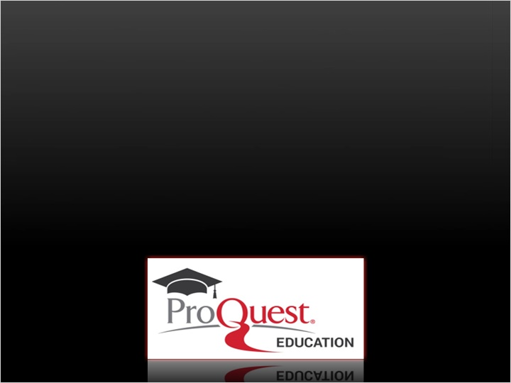
Notes:

1.2 LibCentral: Usage Reports for Administrators
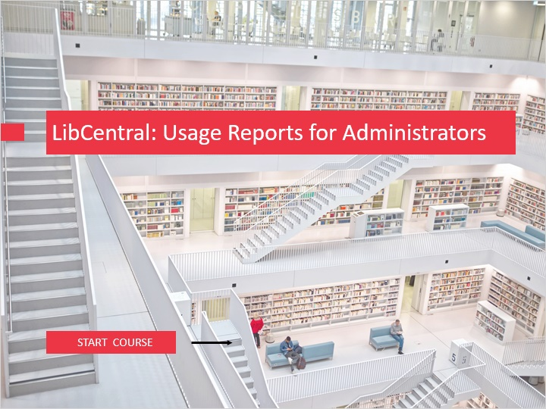
Notes:
Welcome to LibCentral: Usage Reports for Administrators.

Ebook Central Usage Reports provide granular information on all usage of titles in your collection, tracking what is being used, when, and how. The reports can help demonstrate return on your investment, quantify the value of digital resources, and inform ebook acquisition and collection development.

To begin, click on the START COURSE button.

1.3 Objectives
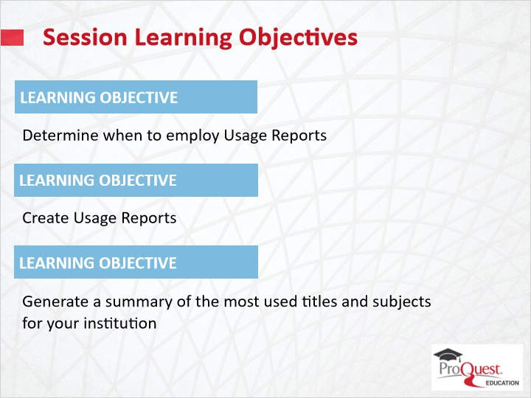
Notes:
The learning objectives for this session are to:

Determine when to employ Usage Reports;
Create Usage Reports; and
Generate a summary of the most-used Ebook Central titles and subjects for your institution.

1.4 Why Usage Reports?
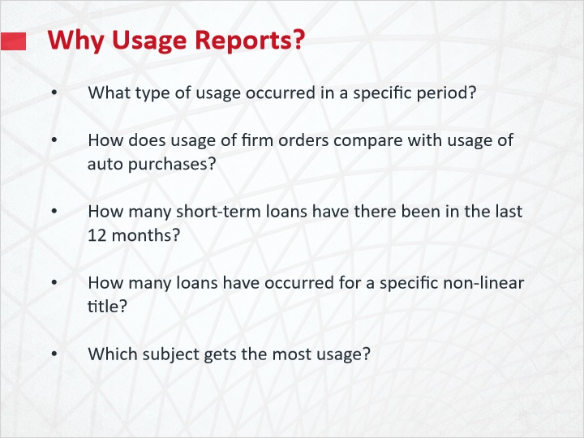
Notes:
How do Ebook Central usage reports help librarians and libraries?

The reports can be used to answer questions like:

What type of usage occurred in a specific period?
How does usage of firm orders compare with usage of auto purchases?
How many short-term loans have there been in the last 12 months?
How many loans have occurred for a specific non-linear title?
Which subject gets the most usage?

1.5 Creating Usage Reports
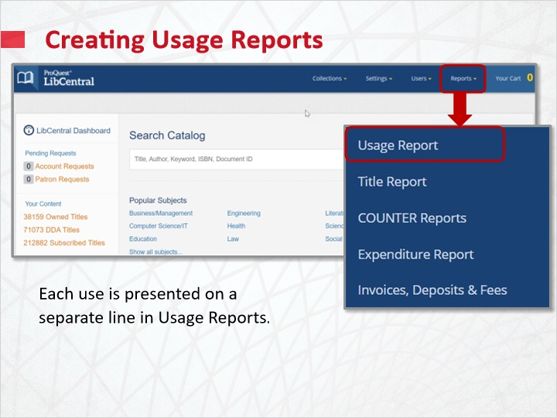
Notes:
To create an Ebook Central Usage Report, click the Reports tab in LibCentral, then click Usage Report.

Ebook Central Usage Reports draw from highly detailed data recorded by Ebook Central logs, and may be used for precise, in-depth analysis. These reports track usage for owned, subscribed and DDA titles. Each usage is displayed as a separate result in the report, so there can be multiple entries for a title. Types of usage tracked include free views, time viewed, pages, downloads, prints, and much more.

1.6 Usage Report Criteria Selection
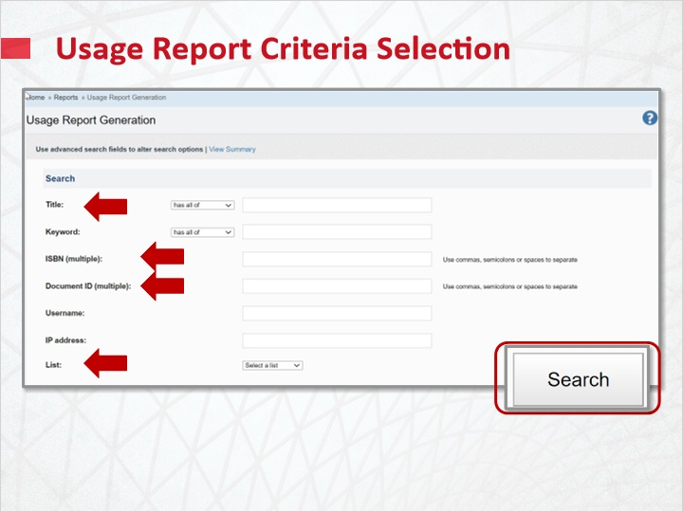
Notes:
To view all usage, click Search at the bottom of the Usage Report Generation page, without entering any search terms or selecting any filters. By default, the most recent 12 months are reflected.

Or, select from multiple criteria to create Usage Reports on subsets of data. To focus on a specific book or books, use Title, ISBN or Document ID. You can also limit the report to a list created previously within LibCentral. See the online Help to learn more about how administrators can create and manage lists.

Or search by Collection, Publisher, Subject or Date.

Purchase Type, Access Model, Use Type and Trigger Events are also available.

Enter your criteria and click Search to run the report.

Note that Consortia will also be given the choice to create a report for all members or specific members.

Additional Criteria (Slide Layer)
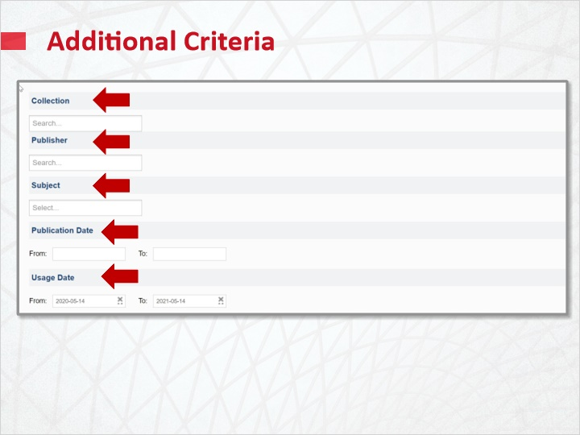

And more... (Slide Layer)
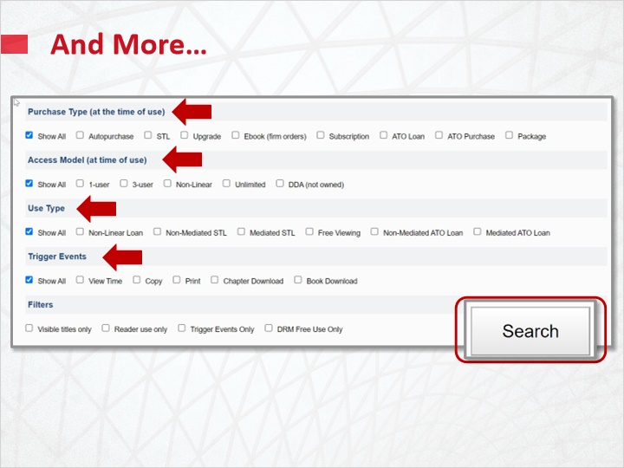

Consortia Option (Slide Layer)
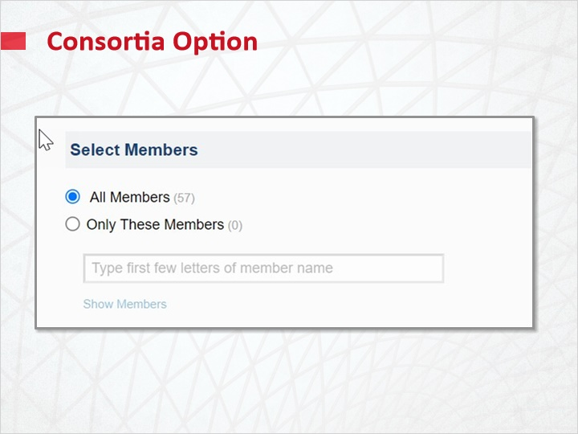

1.7 Usage Report Results
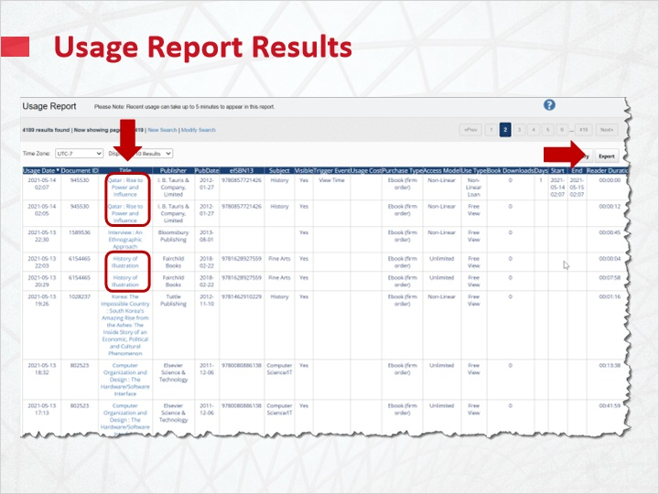
Notes:
The resulting Usage Report is sorted by usage date. Note the multiple entries for multiple uses of titles. Click on any column header to re-sort. Clicking on the Title header will group usage of a title together. The Usage report can be viewed online or exported with additional detail.

If you are looking for cumulative usage for a title instead, use the Title Report found under the Reports tab in LibCentral. Total usage for titles is collated in a Title Report so that each title will have one entry in the report.

1.8 Usage Summary Reports
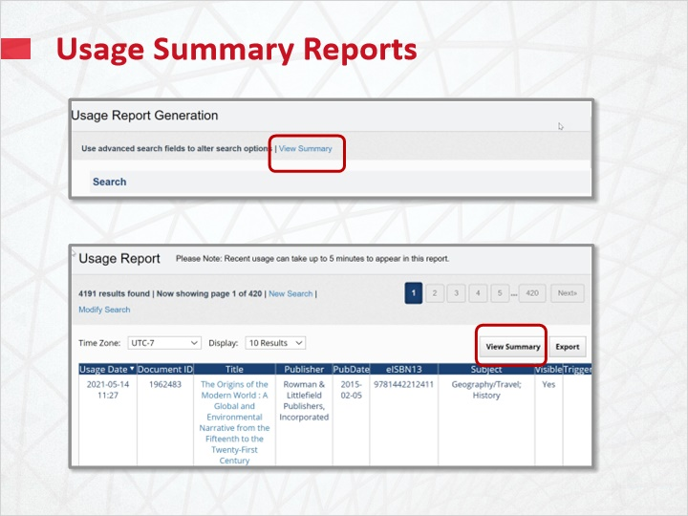
Notes:
To view a summary report of all usage, click View Summary on the Usage Report Generation page.
To view a summary of a filtered Usage Report, click View Summary on the report results page.

1.9 Usage Summary Results
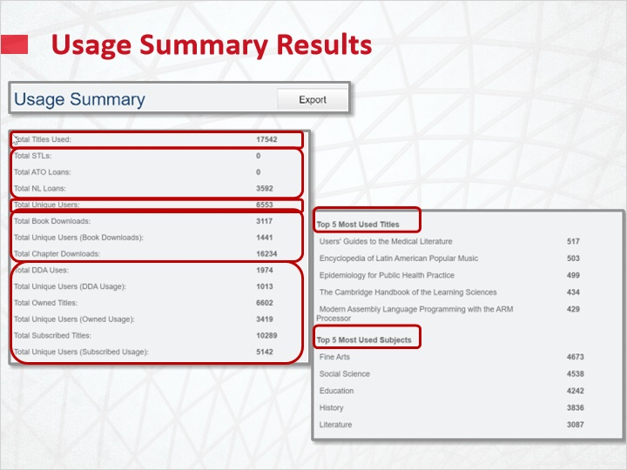
Notes:
The Usage Summary provides total titles, loans, users, and chapter and book downloads. You will also see usage totals split out for DDA, Owned, and Subscribed books. If applicable, total unused auto-purchase and firm order titles since purchase are noted.

The Top 5 Most Used titles and subjects for your institution are easily accessible.

1.10 Test Your Knowledge
(Pick One, 10 points, unlimited attempts permitted)
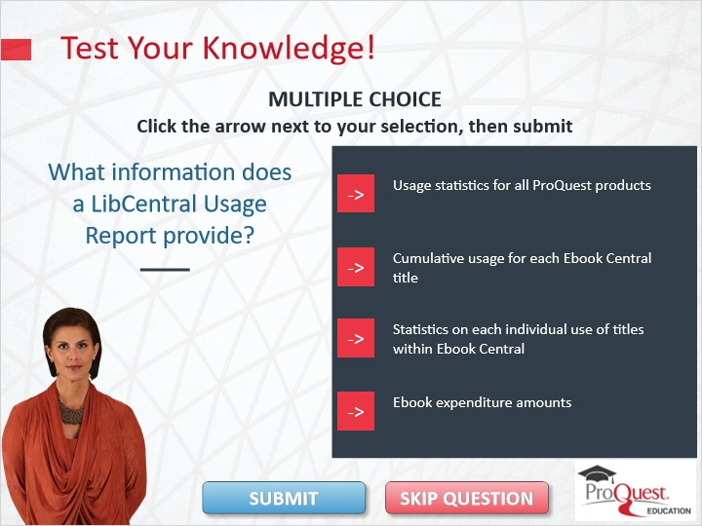
Correct | Choice | Feedback
 | Choice A | The correct answer is statistics on each individual use of titles within Ebook Central
 | Choice B | The correct answer is statistics on each individual use of titles within Ebook Central
X | Choice C | Congratulations!
 | Choice D | The correct answer is statistics on each individual use of titles within Ebook Central

Notes:
Test Your Knowledge!

Click the arrow next to your selection, then submit to check your answer.

What information does a LibCentral Usage Report provide?

Incorrect. The correct answer is Statistics on each individual use of titles within Ebook Central. Press continue to move on.

That’s correct. Congratulations! Press Continue to move ahead.

Thank You 1 (Slide Layer)
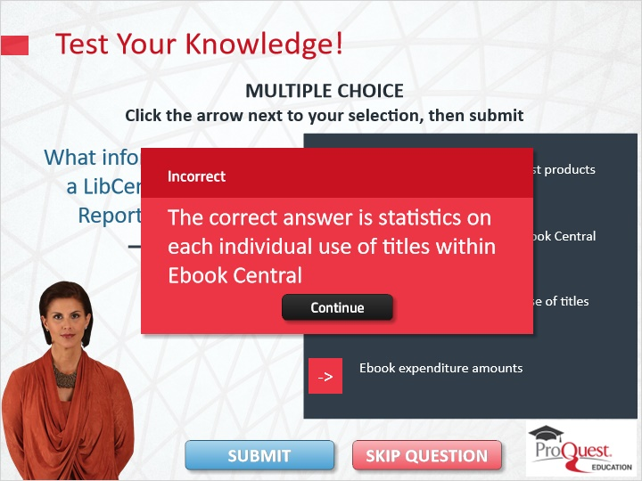

Thank You 2 (Slide Layer)
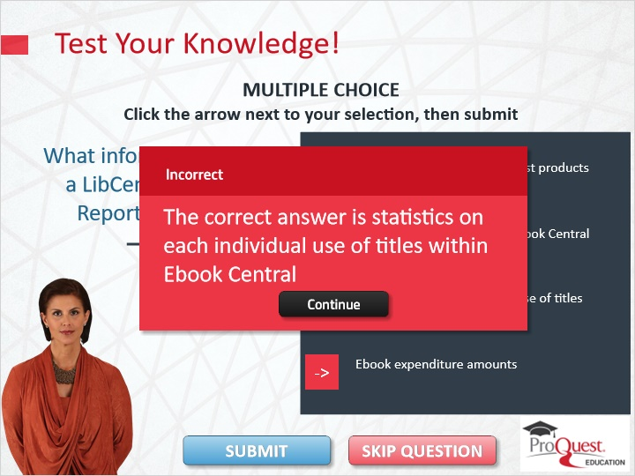

Thank You 3 (Slide Layer)
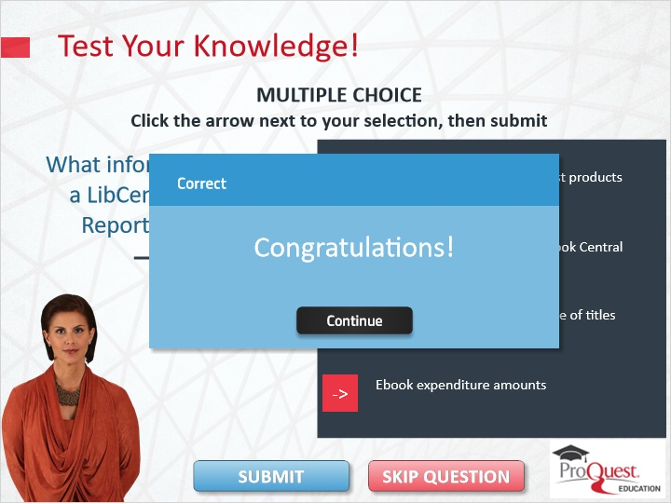

Thank You 4 (Slide Layer)
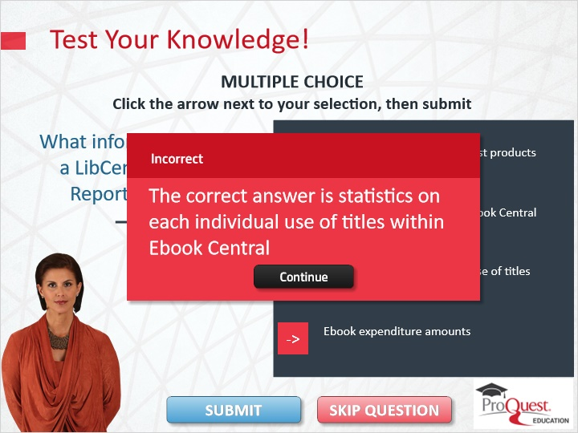

1.11 Summary
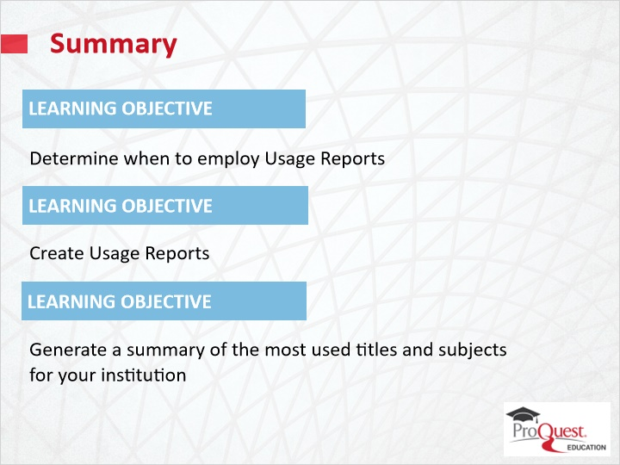
Notes:
This session has covered the following learning objectives:

Determine when to employ Usage Reports;
Create Usage Reports; and
Generate a summary of the most-used Ebook Central titles and subjects for your institution.

1.12 Thank you!
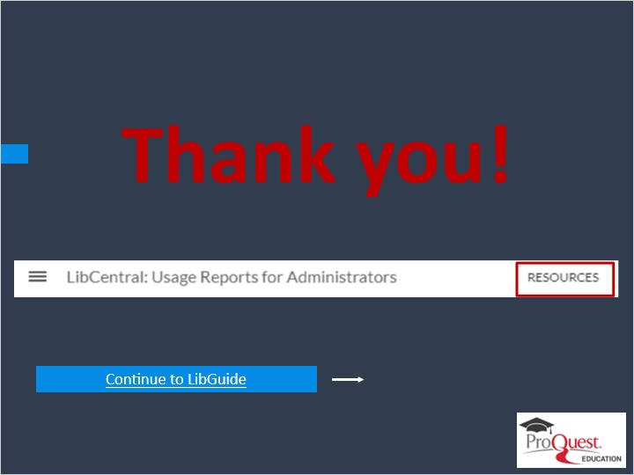
Notes:
This concludes this session. Thank you for joining!

To learn more, please click on the Resources link, as illustrated, in the upper right corner of this session player, or visit our Ebook Central LibGuide Product page by clicking the LibGuide link at the bottom of this screen.

1.13 Copyright
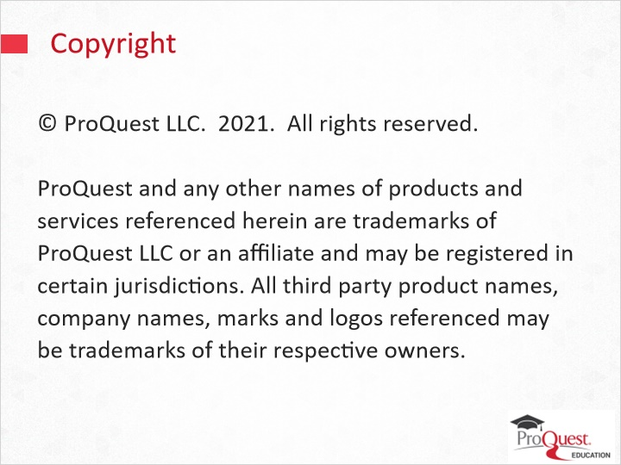
Notes:
© ProQuest LLC. 2021. All rights reserved.
ProQuest and any other names of products and services referenced herein are trademarks of ProQuest LLC or an affiliate and may be registered in certain jurisdictions. All third party product names, company names, marks and logos referenced may be trademarks of their respective owners.

